

PEIMS Fall Submission 1

- PEIMS Responsibilities and Requirements
- Uploading PEIMS Data
- Promoting PEIMS Data
- Validating PEIMS Data
- Searching PEIMS Data
- Verifying PEIMS Reports
- Preparing/Finalizing PEIMS Data



TSDS PEIMS Fall Submission 1

TSDS PEIMS – Submission Responsibilities & Requirements

The Texas Student Data System (TSDS) is a statewide system for collecting and reporting education data for Texas publicly funded schools.

2023-2024 PEIMS Fall Submission Timeline

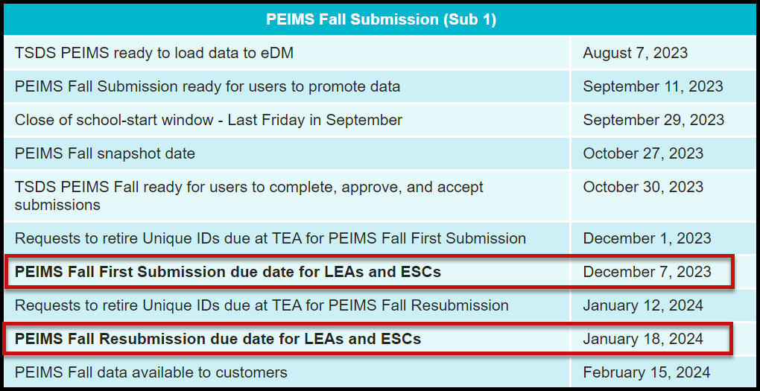

TSDS TWEDS – Texas Education Data Standards

The data submitted through TSDS must be in XML format as defined in TEDS (Texas Education Data Standards). The TEDS is located on the TSDS website.

http://www.texasstudentdatasystem.org/TSDS/TEDS/TEDS_Latest_Release/

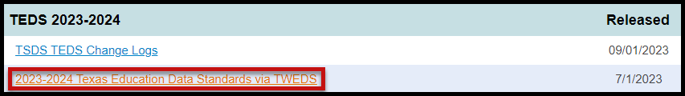

According to TEDS the LEAs (Local Education Agencies) are responsible for:

- Submitting current, complete, and accurate data for all XML files required for each submission
- Validating and editing data according to the business rules and validations
- Correcting all errors during the validation process
- Delivering “fatal-free” corrected PEIMS data on or before any due dates set by the ESC or TEA.

TSDS TWEDS – eDM Dictionaries and Guides

TEDS provides error dictionaries to assist in translating and troubleshooting errors in File Manager and Batch Manager as well as guides for deleting/reloading data. There is also a guide that cross-references validation rules with the associated elements and interchanges.

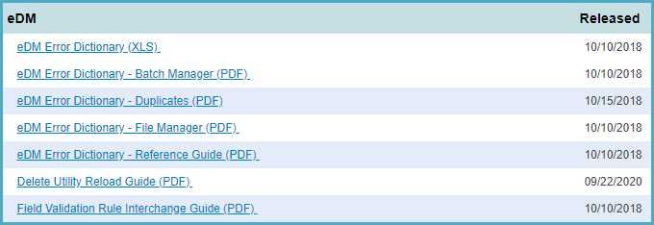

TSDS – PEIMS Access and User Roles

The TSDS PEIMS application is only available to authorized ESC, district, and campus staff. A TEAL logon is required as well as access to the Texas Student Data System Portal. Different roles can be assigned to the user based on the access required. There are several different roles in the PEIMS application, each with a different level of access.

- ODS Data Loader (ESC/LEA) – This role allows the user to upload PEIMS Interchanges to TSDS.
- PEIMS Campus Submitter (Campus) – This role allows the user to promote loaded data, validate (prepare) data, search all PEIMS data, and view PEIMS reports for a specific campus.
- PEIMS Data Submitter (LEA) - This role allows the user to promote loaded data, validate (prepare) data, search all PEIMS data, and view PEIMS reports at the district level.
- PEIMS Data Completer (LEA PEIMS Coordinator) – This role allows the user to promote loaded data, validate (prepare) data, complete (finalize) data, search all PEIMS data, and view reports at the district level.
- PEIMS Data Approver (LEA Superintendent) – This role allows the Superintendent to approve the PEIMS data submission and apply for an extension if necessary.
- PEIMS Data Accepter (ESC) - This role allows the user at the ESC to view and run reports, accept, or reject the PEIMS data submission.

Downloading Validation Tool (Version 14.0.0 updated 10/13/2023)

TEA provides a Validation Tool to validate the format and naming conventions for the PEIMS interchanges. The Validation Tool is located in TEAL>Texas Student Data System Portal>Utilities for downloading.

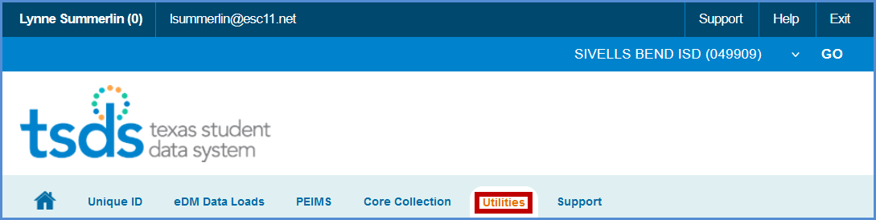
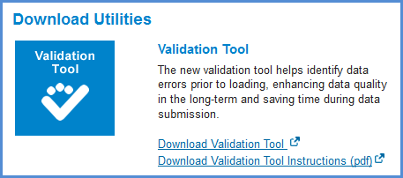

- Click Download Validation Tool to download the tool.
- Click Download Validation Tool Instructions (pdf) to download a copy of the installation instructions.

Note: If you have previously installed the Validation Tool, the Check for Updates option in it does not update to the most current version. You must download and install the Validation Tool again.

Validating PEIMS Interchanges – Validation Tool

Once the Validation Tool has been downloaded and installed click on the validation tool icon to open the tool.

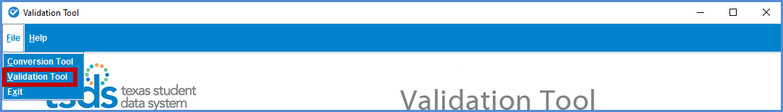

- Select File > Validation Tool. The Validation Tool opens in a separate window.

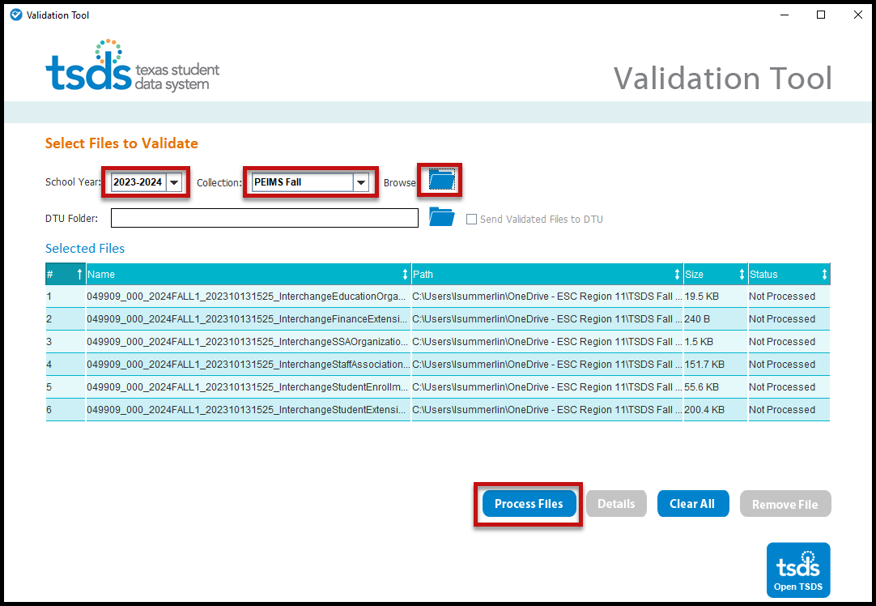

- Select the School Year 2023-2024.
- Select the Collection.
- Click the folder icon to browse for and select the PEIMS files (files must be unzipped).
- Click Process Files. The results of the validation are reported in the status field.
- If you have files that Fail, you can click on the file name and click the Details button.

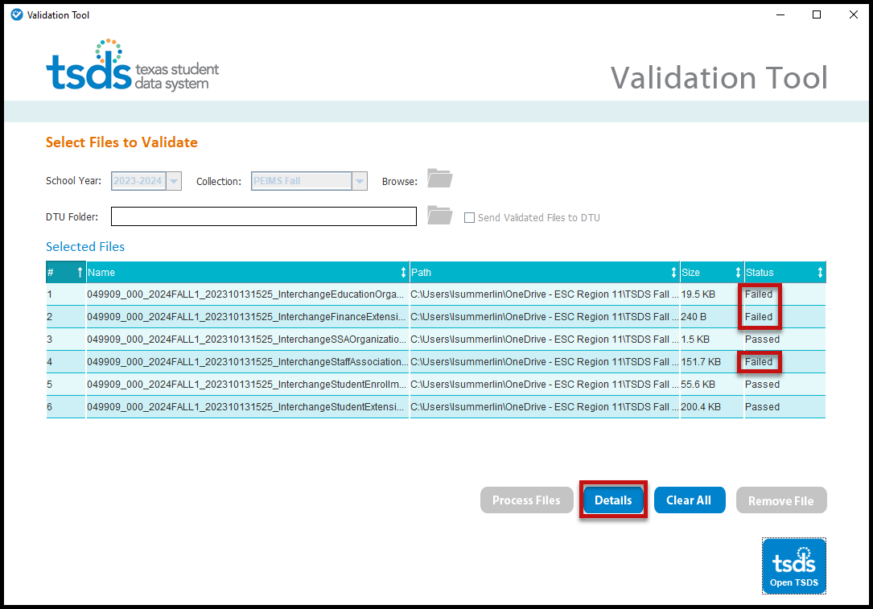

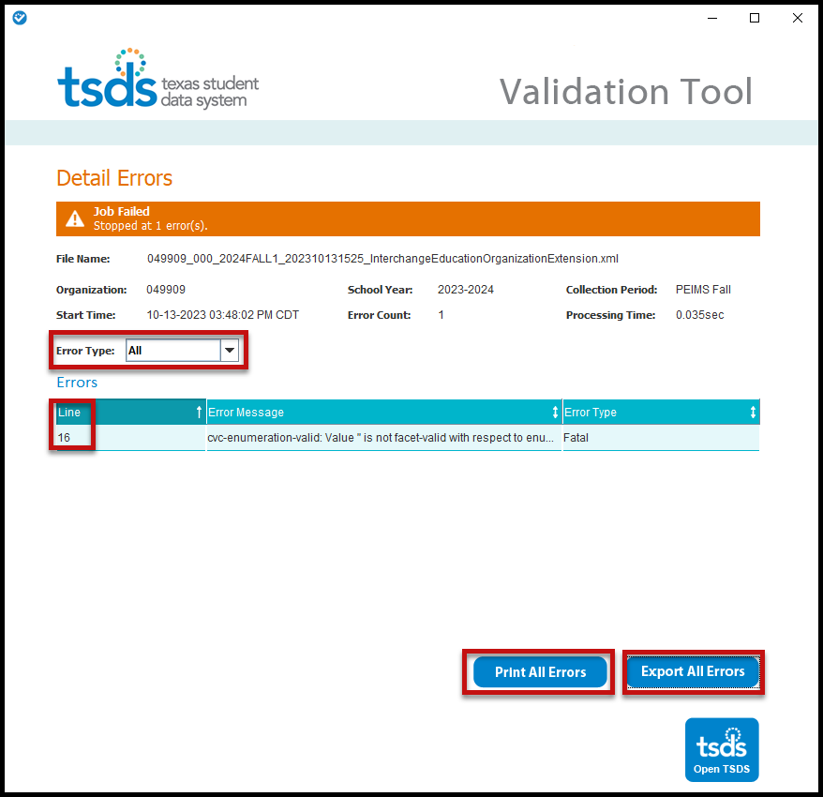

- The Detail Errors page appears, errors can be viewed on screen by selecting Error Type (All, Fatal, Warning, or Special Warning).
- Errors may also be printed by selecting Print All Errors or saved in Excel format by selecting Export All Errors.

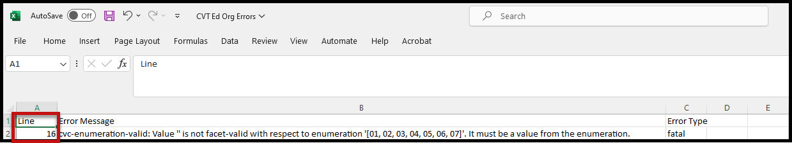

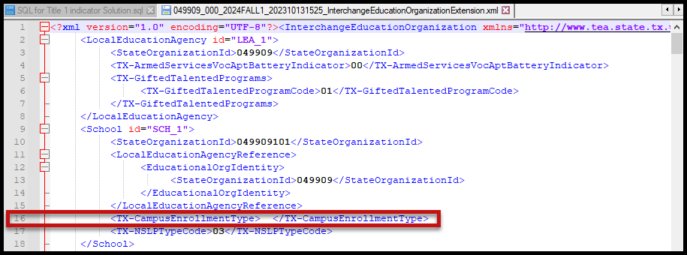

- Files can be manually loaded in TSDS by clicking on the Open TSDS button. This will take you to the TEAL login screen.
.
Note: Failed files will not load in the ODS. Files with errors will load, but errors will need to be corrected prior to finalizing the PEIMS Submission.

Uploading PEIMS files – TSDS PEIMS Data Upload

The TSDS portal is the way to access any of the TSDS applications or utilities to which users have access. The tabs that appear on the portal depend upon the access that has been granted in TEAL.

The eDM Data Loads tool allows users to load data from their local systems to TSDS.

- Once logged into TEAL and select Texas Student Data System Portal.
- On the Home screen select Manage Data Loads.

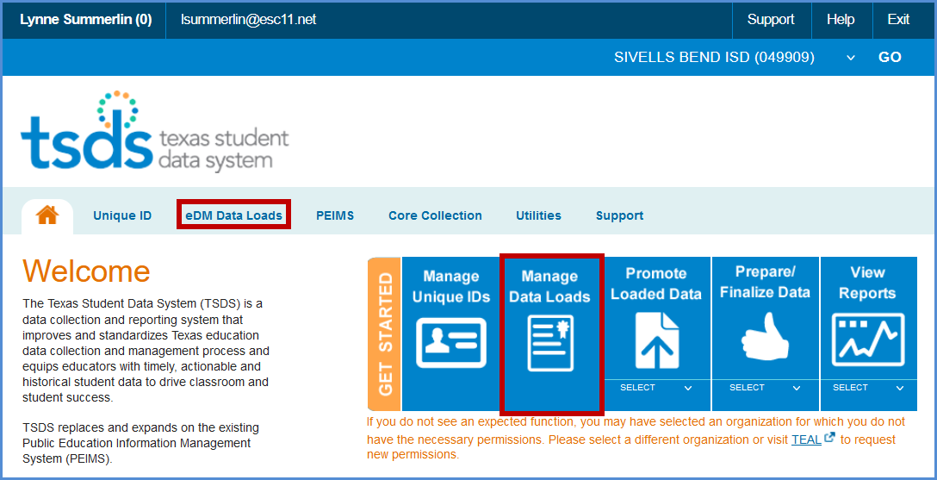

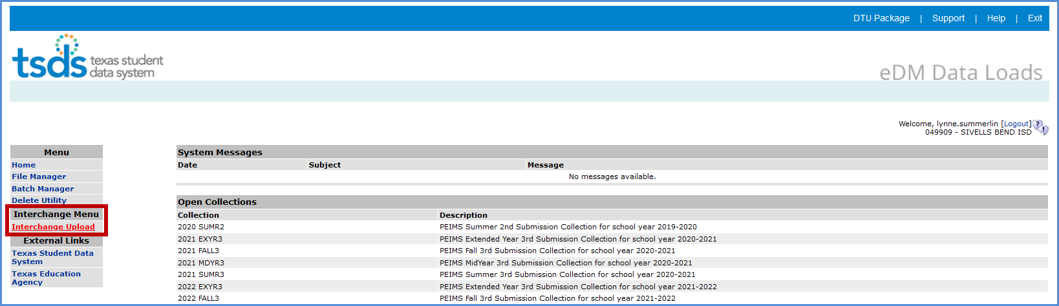
- Under Interchange Menu, select Interchange Upload.

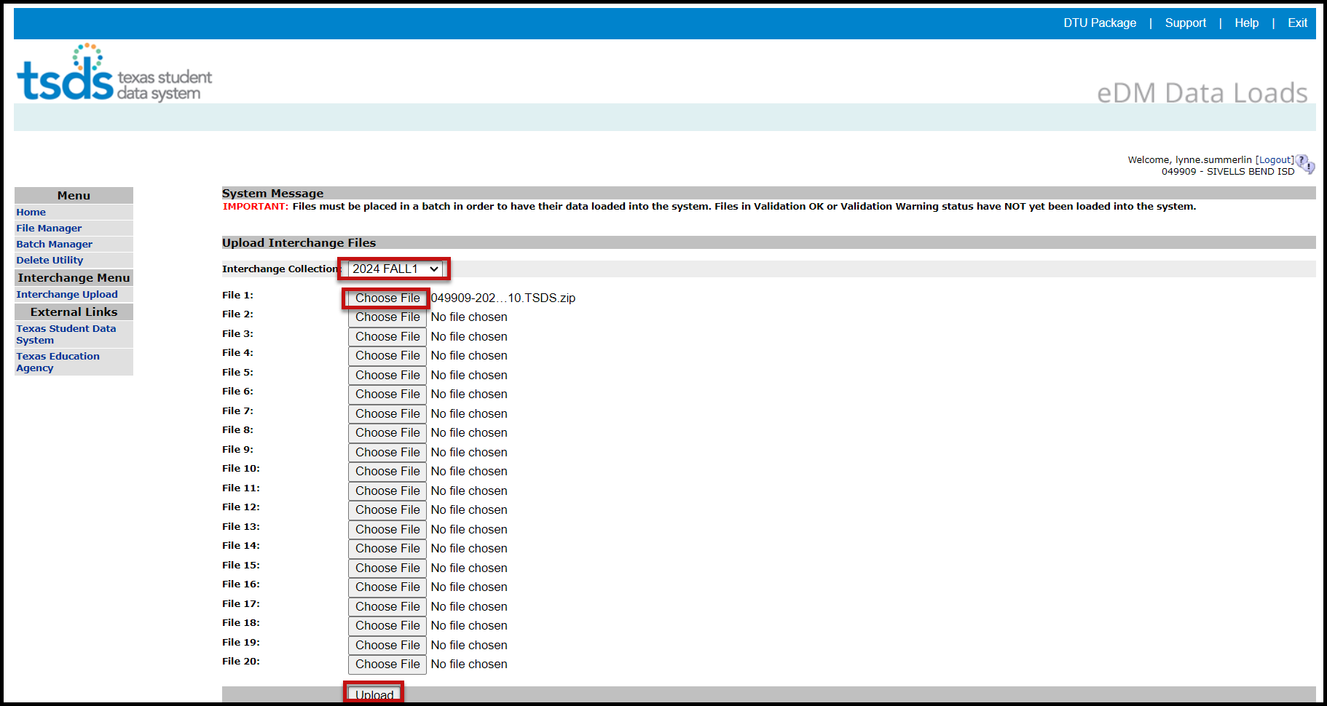

- Select the Interchange Collection from the drop-down menu.
- Click the Browse button for File 1 and select the file from your computer.
- Click the Browse button for File 2 and select the next file from your computer.
- Continue until all required files have been selected.

Note: The files must be loaded in the following order:

- InterchangeEducationOrganizationExtension
- InterchangeStudentExtension
- InterchangeStudentEnrollmentExtension
- InterchangeStaffAssociationExtension
- InterchangeStudentProgramExtension
- InterchangeSSAOrganizationAssociationExtension
- InterchangeFinanceExtension

- Click Upload. The files are validated and uploaded to the File Manager.

Note: Files can be zipped for easier upload. Select all files, right click, Send to>Compressed (zipped) folder. Upload the one file.

- Once the files have been completely uploaded, the File Manager screen appears.
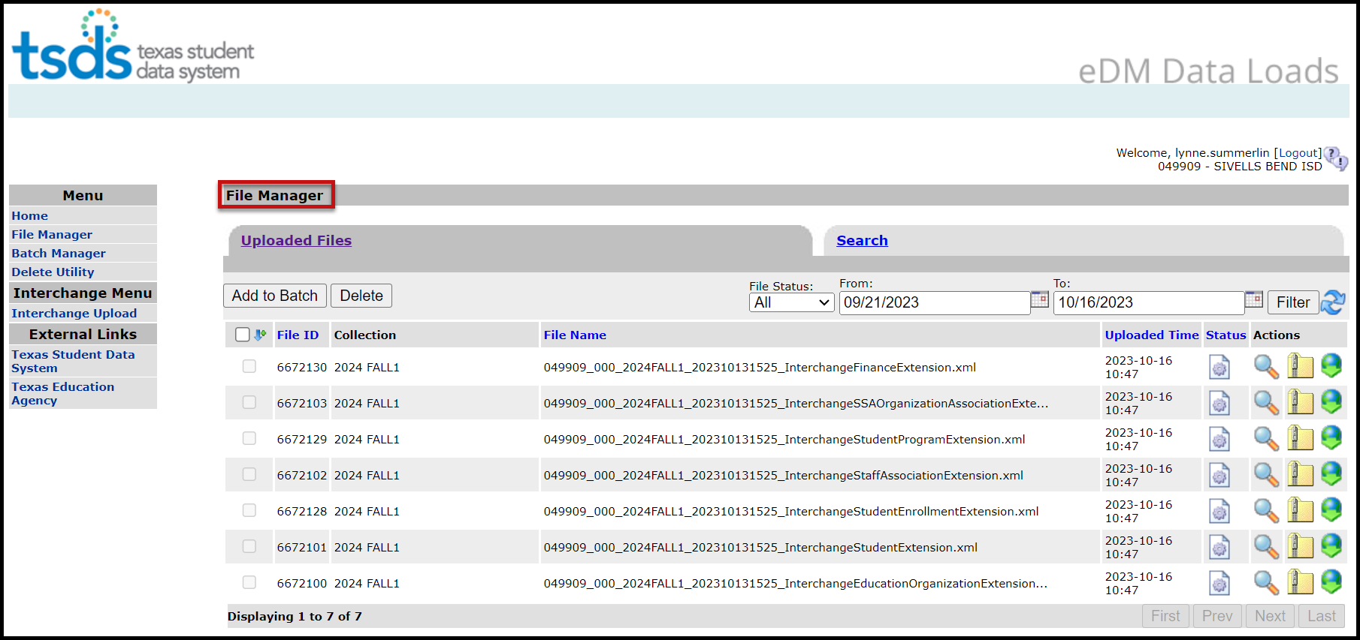

- The files will be processed for errors.
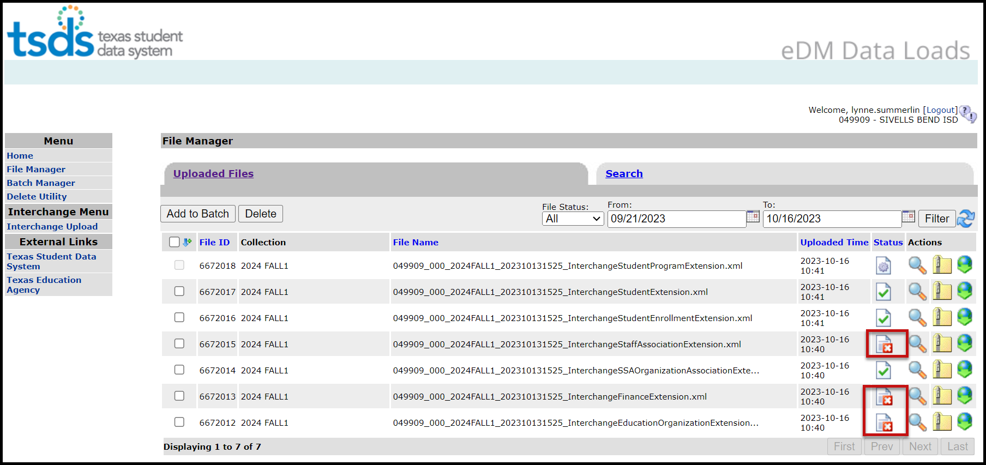
- Any failed files  will not batch.
- Any files with errors will have a red in the status column. To view errors click on the spyglass and scroll to the bottom of the screen and open the .TAB file.
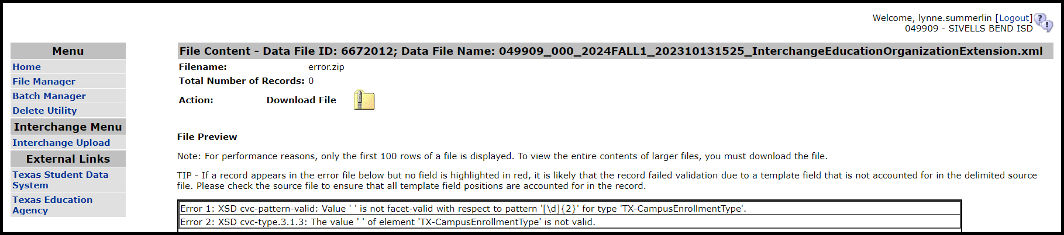

- Make all corrections necessary in the software, run the Validation Tool again, and resubmit the files.
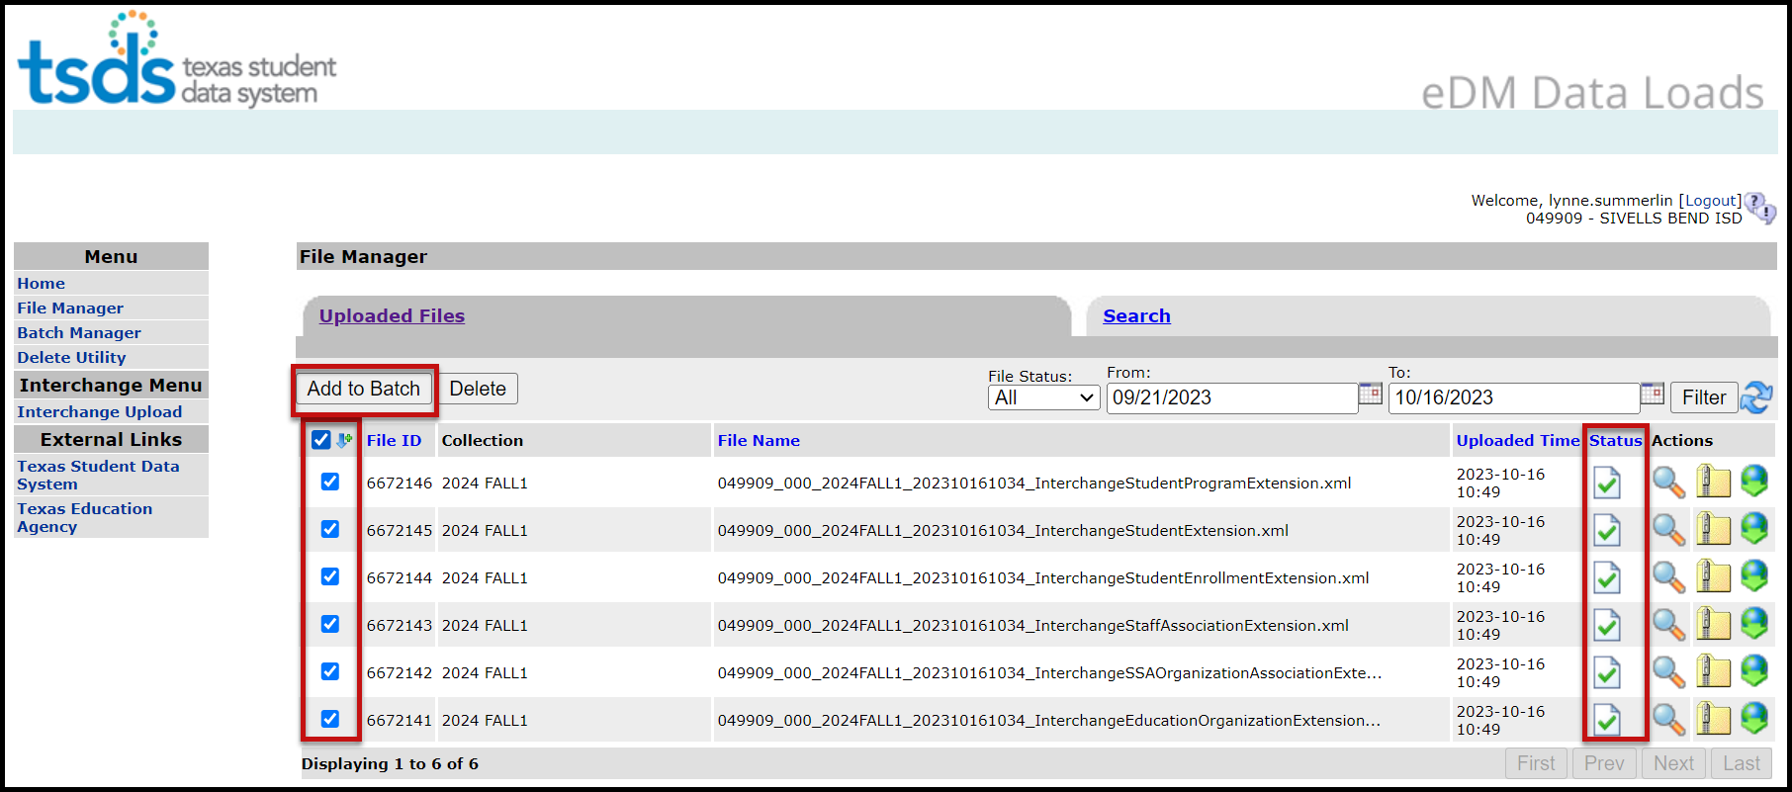
- Once all the files have a green checkmark in the status column, select all of the files and click Add to Batch. The View Batch button appears.

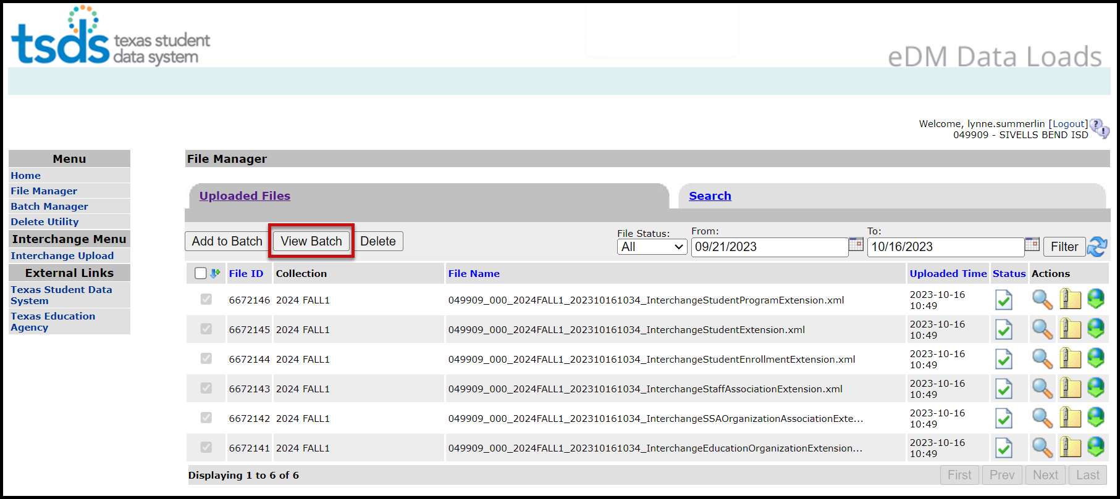
- Select the View Batch button.
- From the next screen the user may add comments regarding the batch, remove files from the batch, delete files, or process the batch. It is suggested that comments be added naming the file if the files are being uploaded manually.

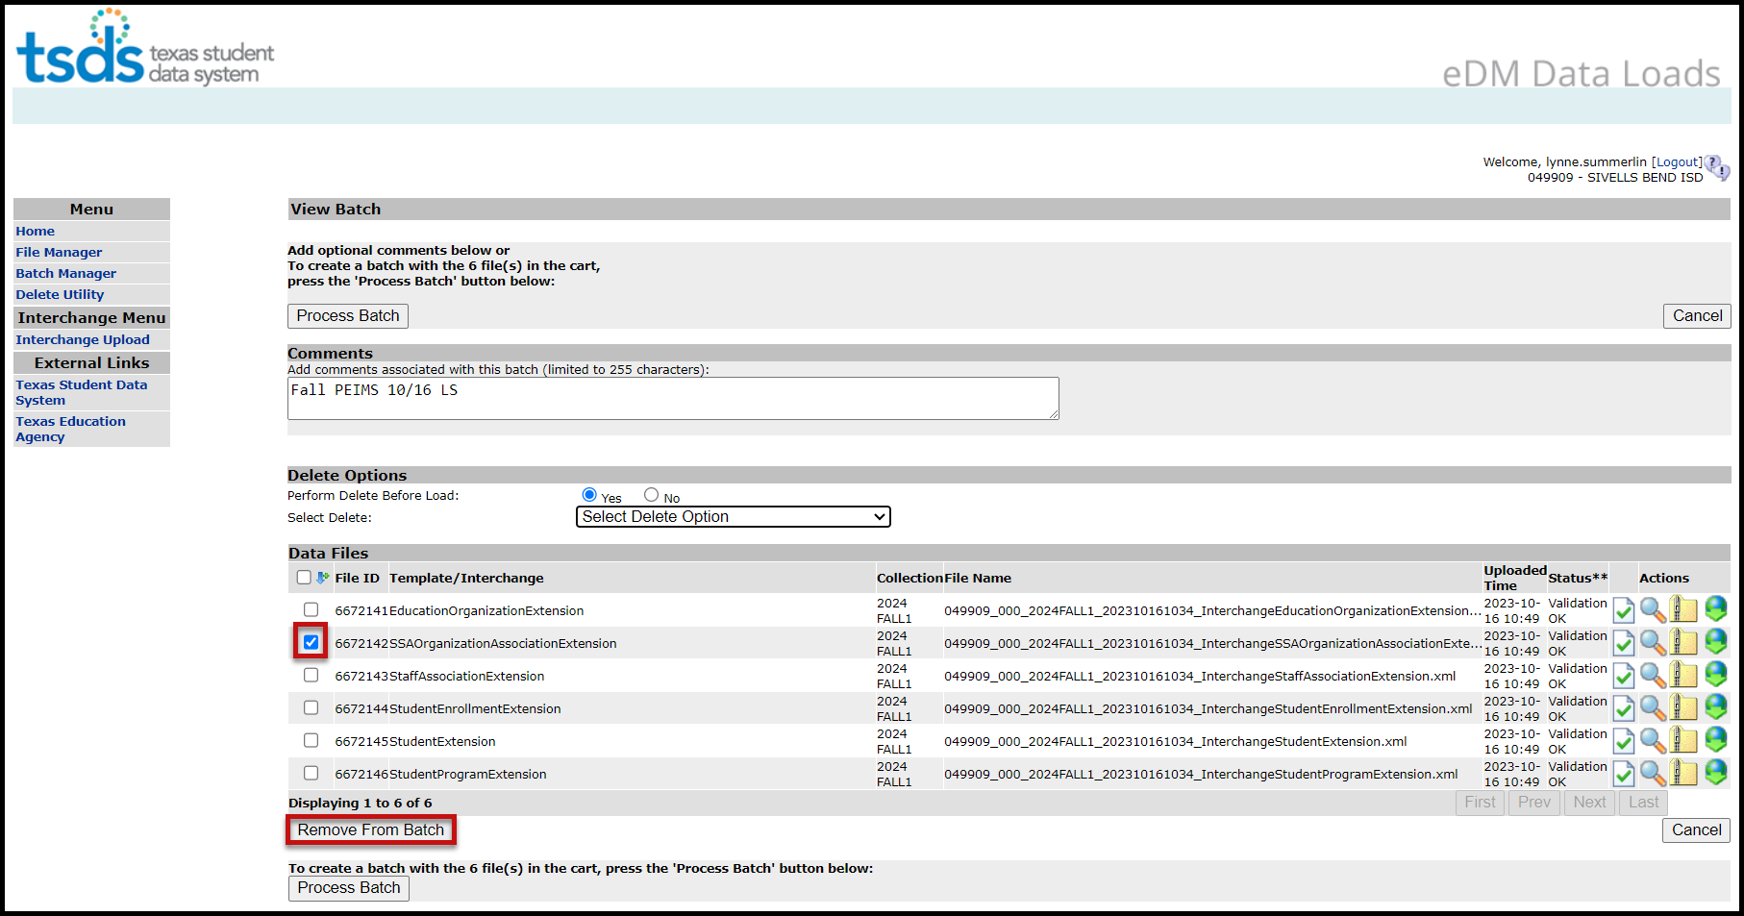
- To remove files from the batch, select the appropriate files and click Remove from Batch.
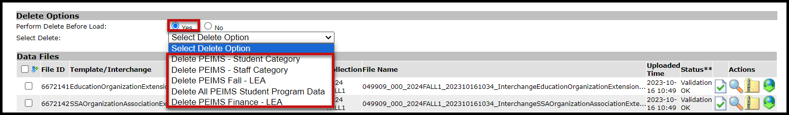
- The selected file is removed from the View Batch screen but remains in the File Manager.
- Districts can delete data prior to processing the new batch. The Delete Utility has been integrated into the Batch Manager process.
- To delete data, select Yes by Perform Delete Before Load.
- From the Select Delete Option pulldown, select the data to be deleted.

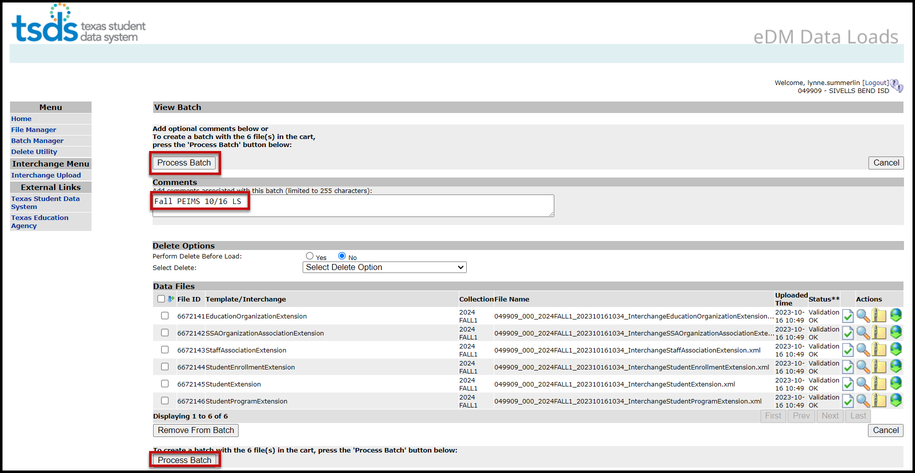
- To process the batch, select the appropriate files and click Process Batch. The Batch Manager screen appears:

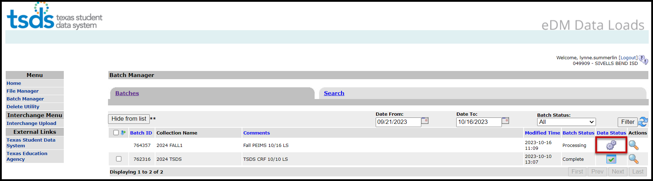

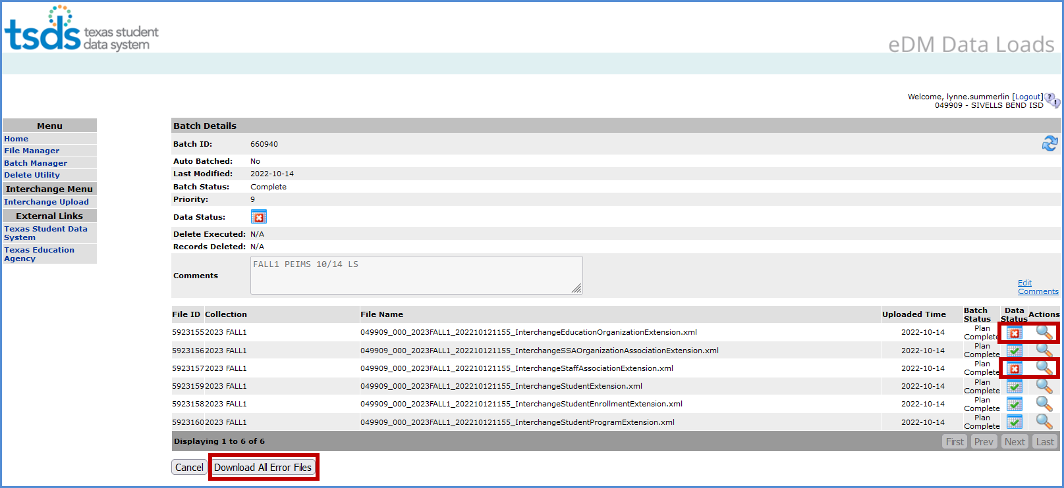
- The Batch Manager screen appears with a list and status of all batches that have been processed. Batches can have a completed status with errors (red X) or no errors (green checkmark).

- To view the files with errors, click the spyglass to open the batch and then click on the spyglass next to the file with errors; or
- Click on Download All Error Files.

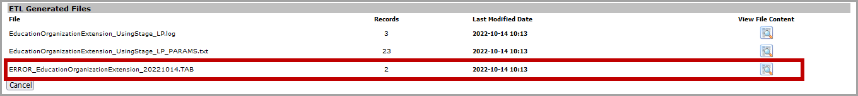

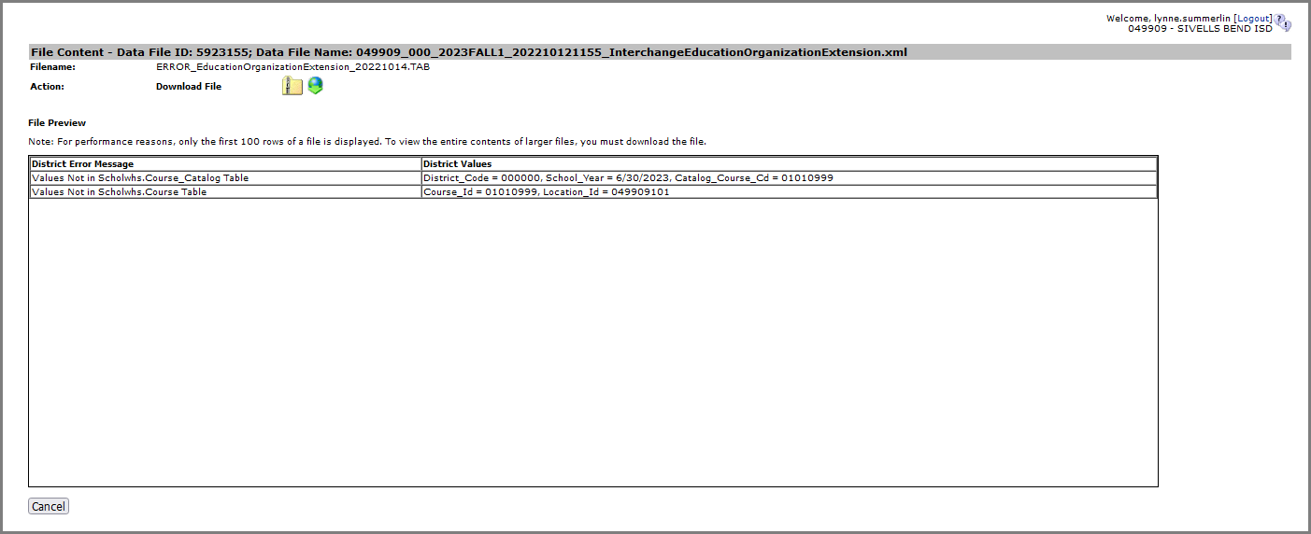
- To view the actual errors, click on the spyglass next to the ERROR.TAB file or the DUPLICATES.TAB file.

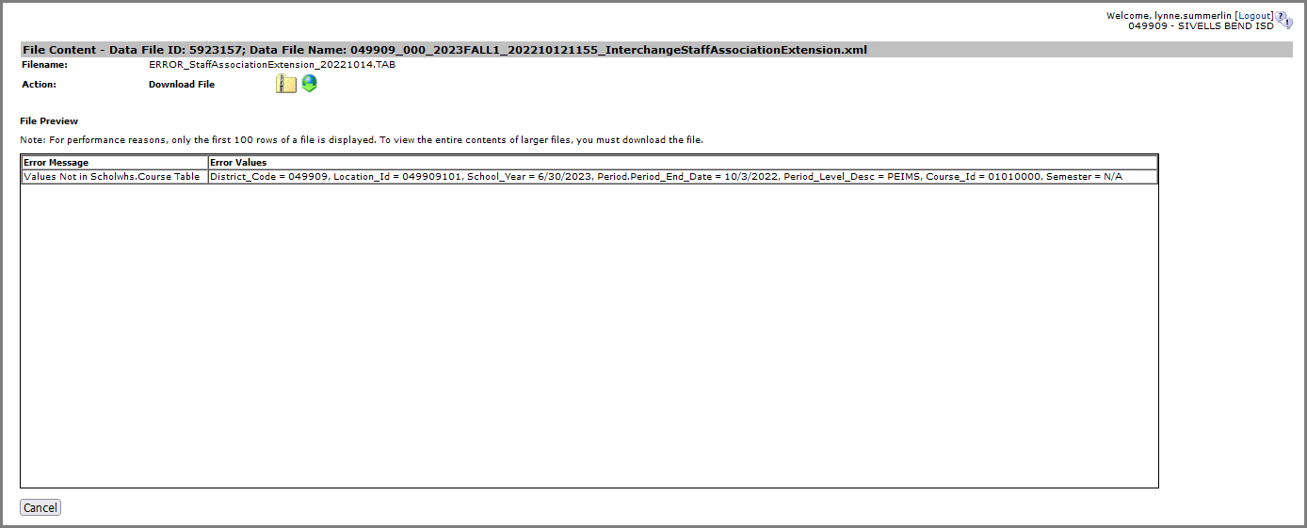

- Click Cancel to return to previous screens.
- Make corrections as needed in the software, create new interchanges, validate again, and resubmit the files.
- Logout and Exit programs.

Promoting PEIMS files – TSDS PEIMS Promote Loaded Data

The eDM Promote Loaded Data tool allows users to promote data that has been loaded and batched.

- Log in to TEAL and select Texas Student Data System Portal.
- On the Home screen select PEIMS>Promote Loaded Data.
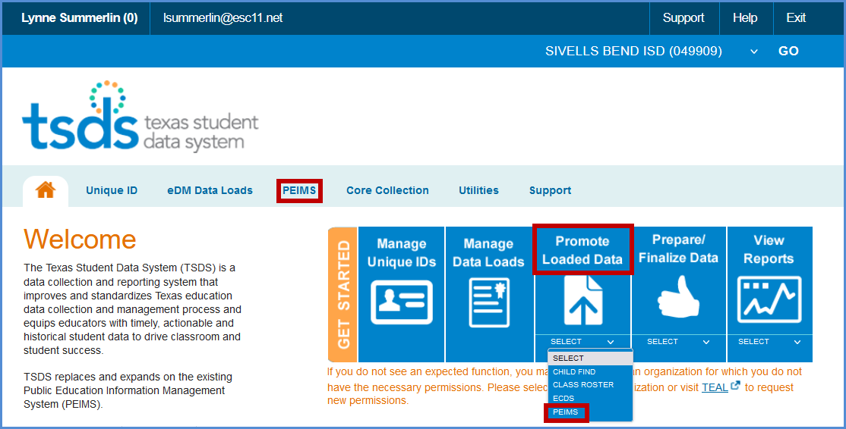

- The Data Promotion screen appears:

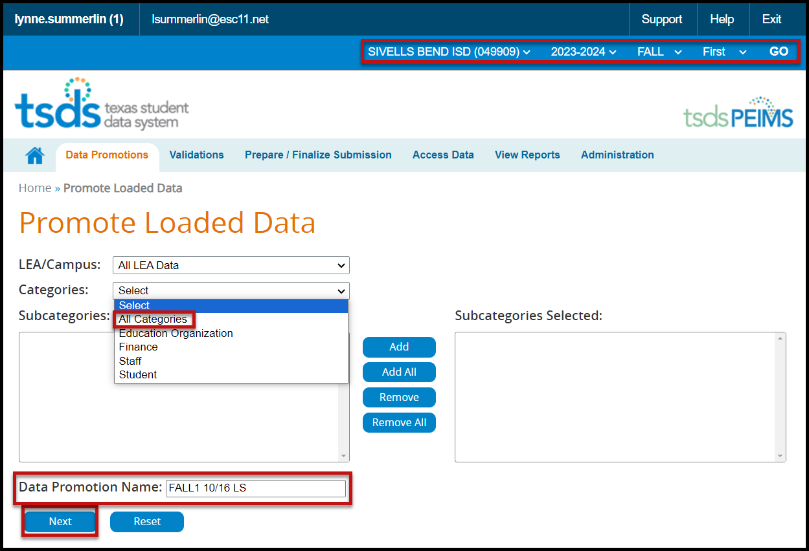

- Verify the correct submission is selected. If not, select it from the pull-down menu and click GO.
- From the Categories pull-down menu, select All Categories or the individual categories to be promoted. If individual categories are selected user may also select individual subcategories.
- Enter a Data Promotion Name.
- Click Next to continue or Reset to clear selections.
- The Confirm Data Promotion screen appears:

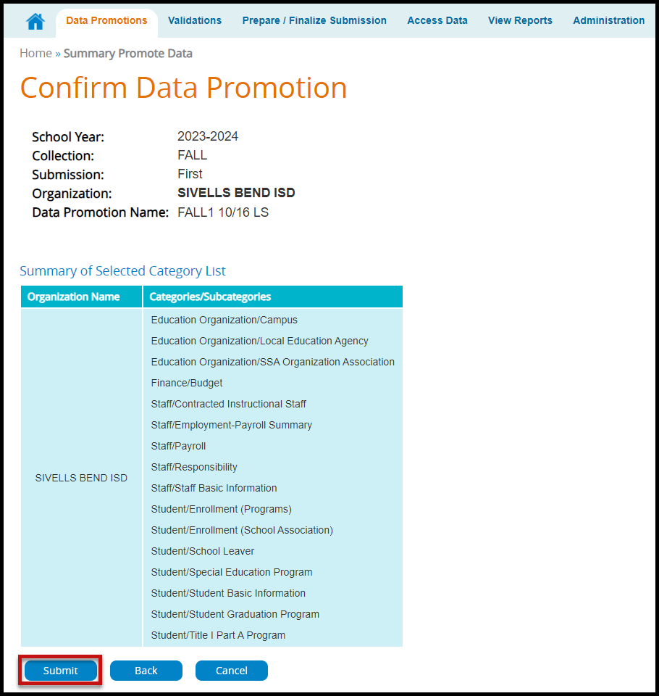
- Verify the Categories/Subcategories.
- Click Submit, Cancel, or Back.
- The Monitor Data Promotions screen appears:

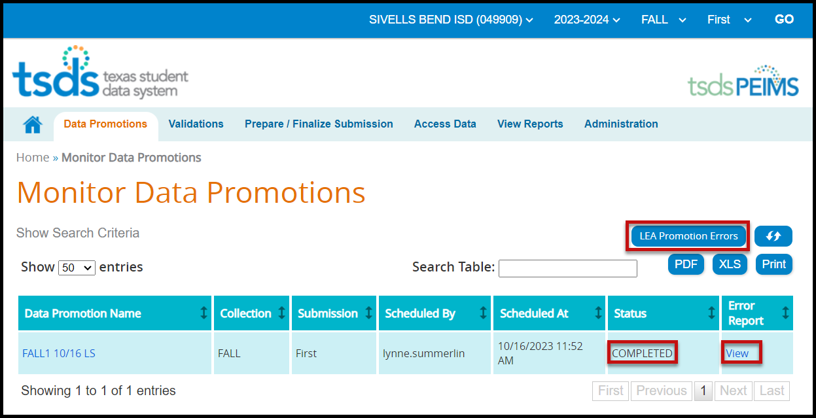

- This screen shows the status of the data promotion, promotion error reports, and a confirmation message that the data was promoted.
- To view promotion errors, click the View link under Error Report or click the LEA Promotion Errors button.
- The LEA Data Promotion Errors screen appears:

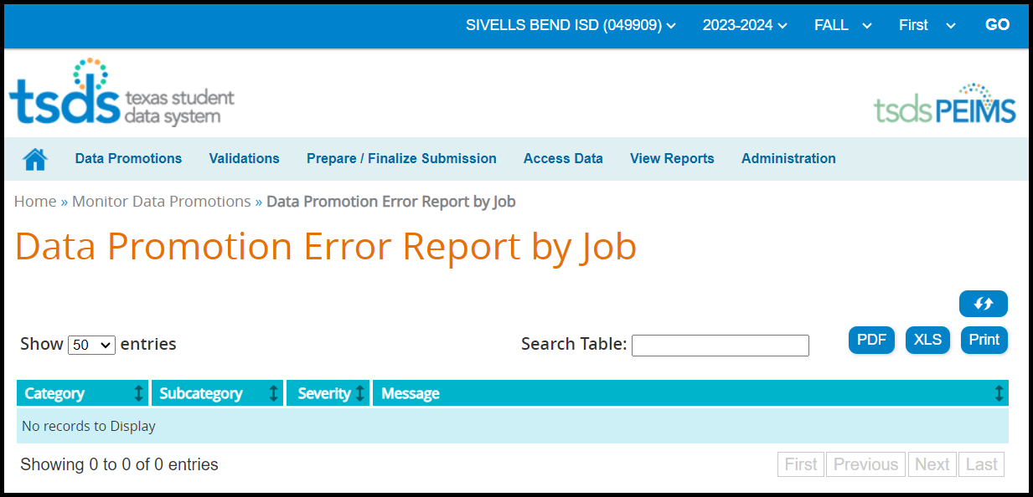

- This screen will list any errors by Category, Subcategory, Severity, along with the error message. Errors can be saved as a PDF or XLS file or can be printed by selecting the appropriate button.

Validating PEIMS files – TSDS PEIMS Promote Loaded Data>Validations

allows users to validate data that has promoted in TSDS. This is where the district will be able to view the Fatals, Warnings, and Special Warnings for the submission.

- Log in to TEAL and select Texas Student Data System Portal.
- On the Home screen select Promote Loaded Data. Select the Validations tab>Validate Submission Data.

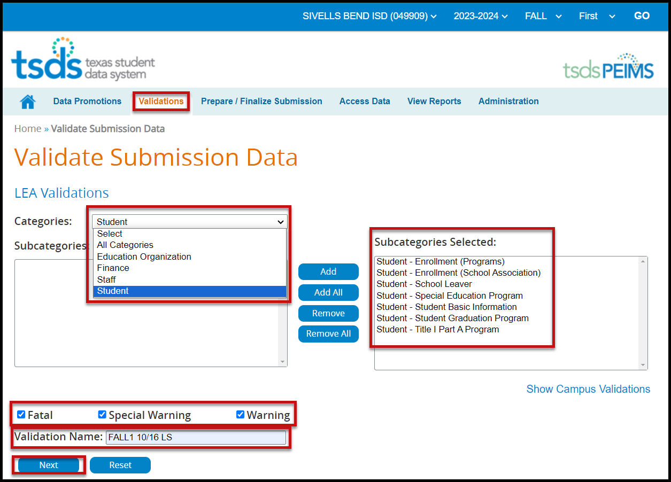

- From the Categories pull-down menu, select All Categories or the individual categories that are to be validated.
- Select the type of validation (Fatal, Warning, Special Warning).
- Enter a Validation Name.
- Click Next to continue the process or Reset to clear all options.
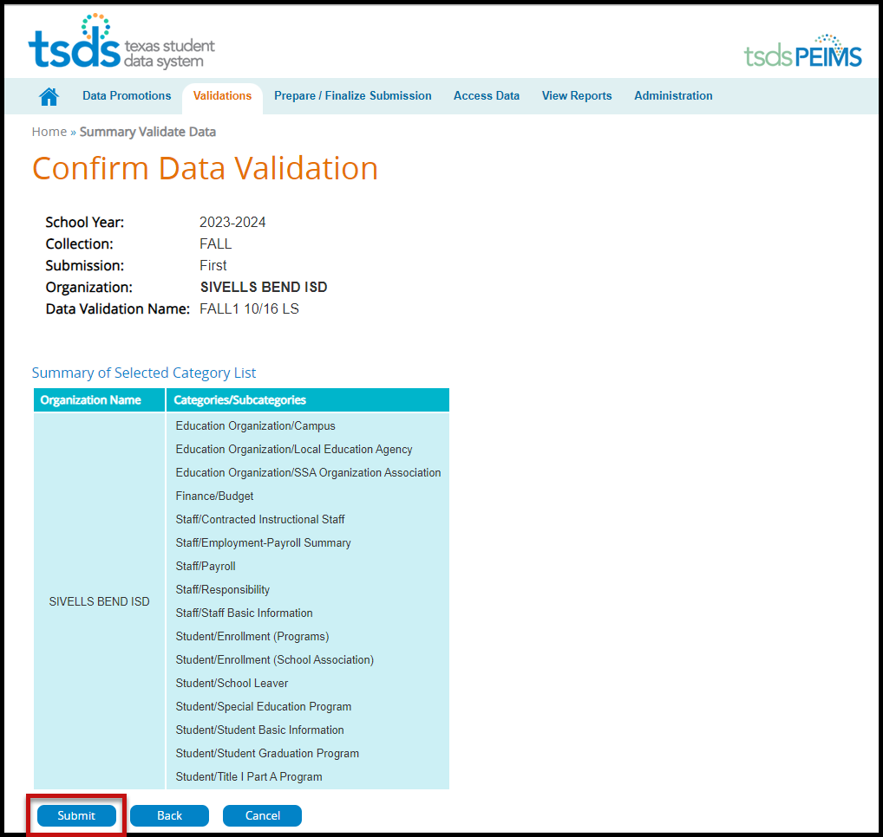
- The Confirm Data Validation screen appears:

- Verify the Categories/Subcategories.
- Click Submit, Cancel, or Back.
- The Monitor Data Validations screen appears:

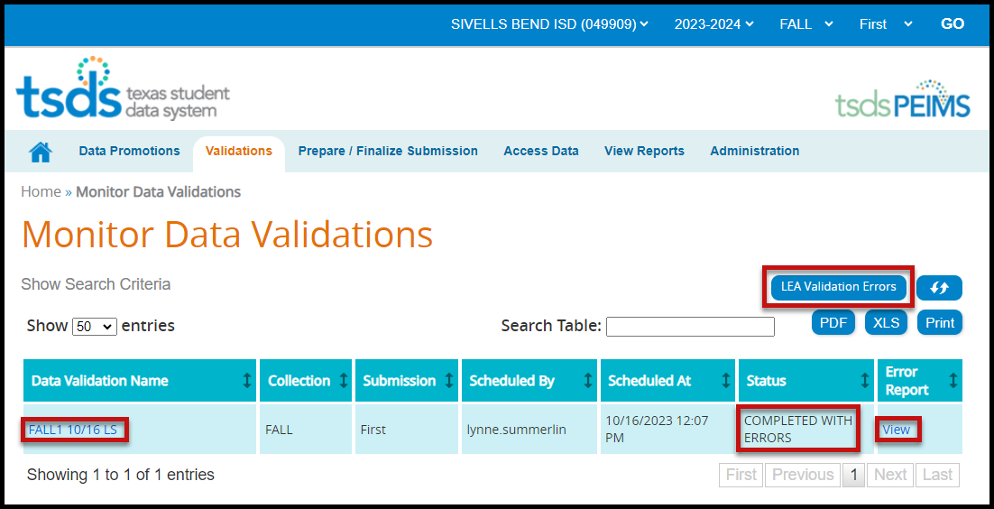

- This screen shows the status of the data validations, validation error reports, and a confirmation message that the data has been submitted.
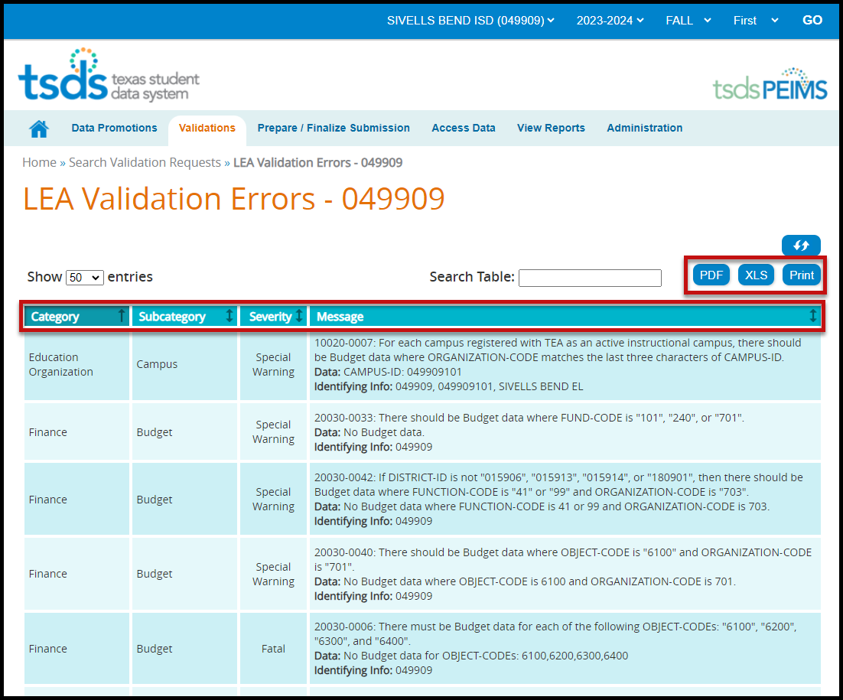
- To view validation errors by job, click the LEA Validation Errors button or View under Error Report.

- This screen will list any errors by Category, Subcategory, Severity, along with the error message.
- Errors can be sorted by individual columns. The errors can also be saved as a PDF or XLS file or can be printed by selecting the appropriate button.

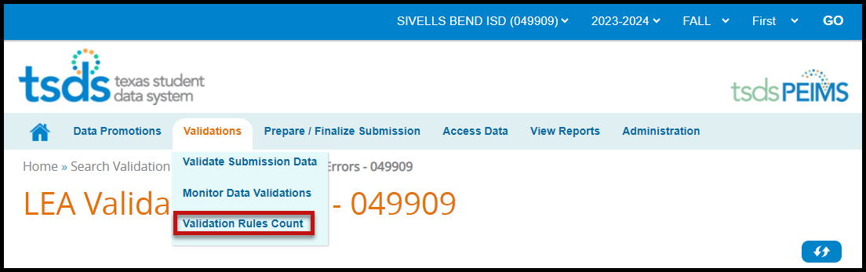

- To view errors by severity (Fatal, Special Warning, and Warning) select Validation Rules Count from the Validations pull-down.
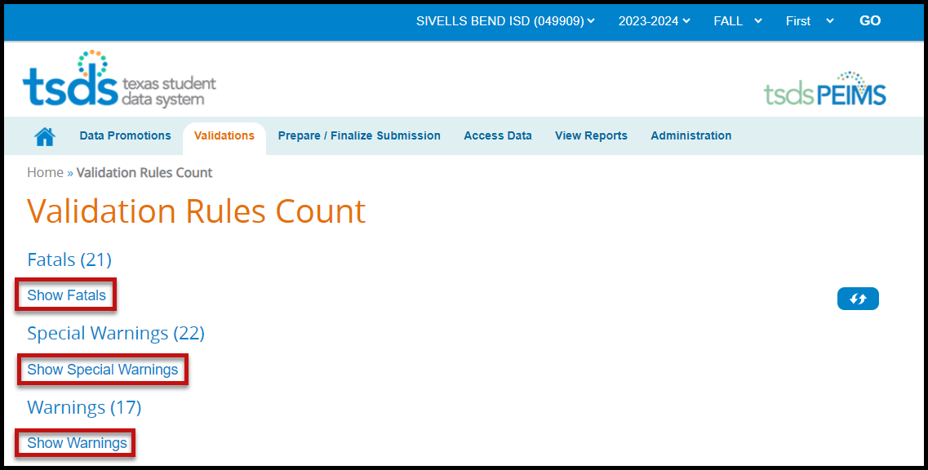

- Click on the “Show” link to view errors.

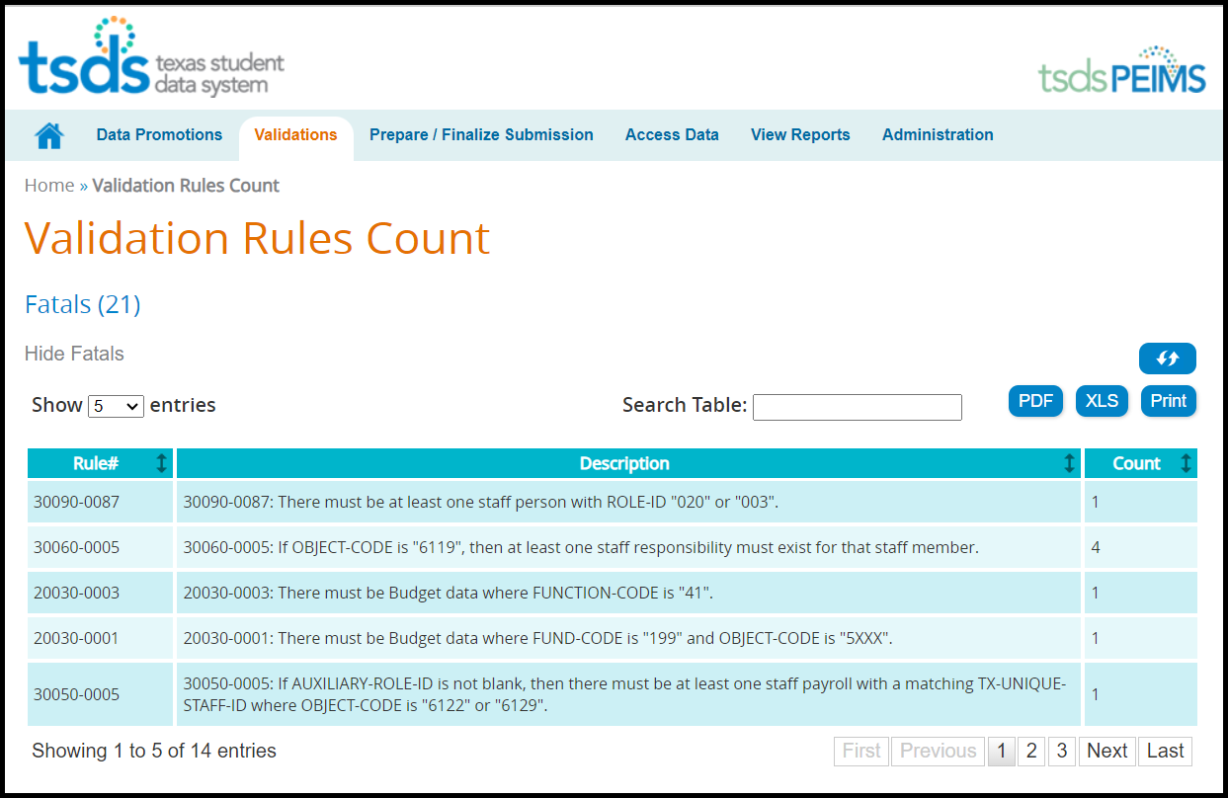

- Correct any fatals. Verify or correct any warnings or special warnings in the database, re-create the files, upload, and promote and validate the data.

Note: It is recommended that the district uses the Delete Utility in TSDS>Manage Data Loads to clear the incorrect data from the ODS prior to uploading the new files.

TSDS – Search Data - TSDS PEIMS Promote Loaded Data>Access Data

To access the data or student rosters, click on the Access Data tab and select either Search Submission Data or Search Student Roster.

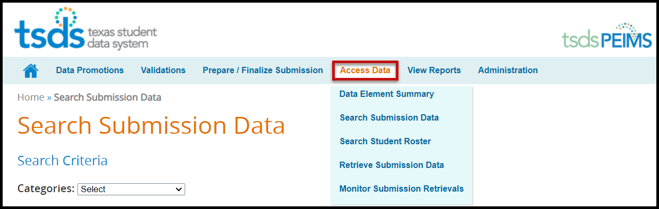

Accessing PEIMS data using Search Submission Data

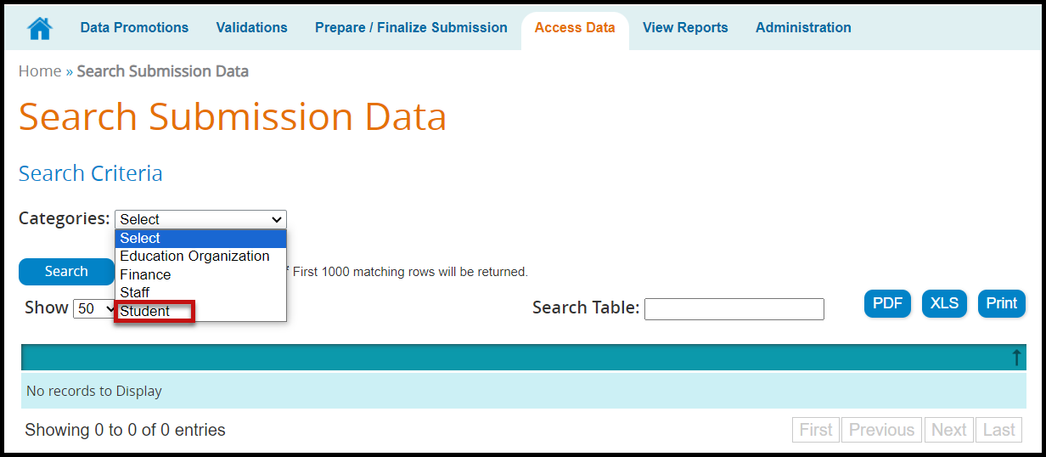

- On the Search Submission Data screen, select the search category from the Categories pull-down menu. The Subcategories field appears:

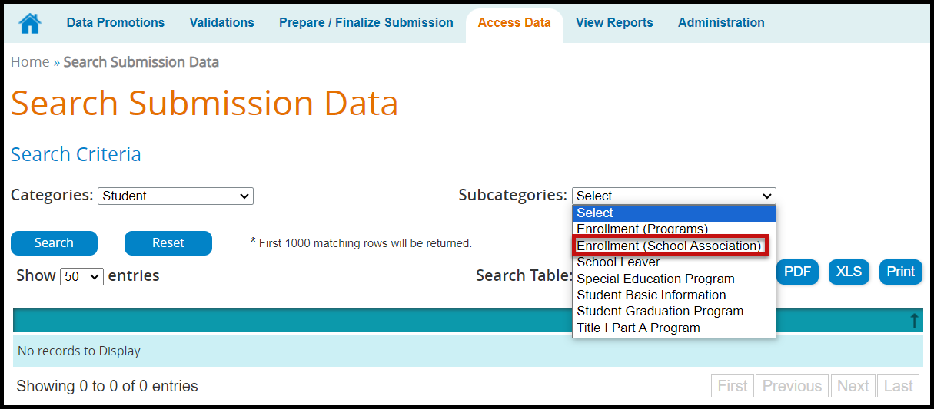

- Select a Subcategory from the pull-down menu if required. Once selected, additional fields appear based on the original category and subcategory selected. At least one required field (*) must be entered to complete the search.

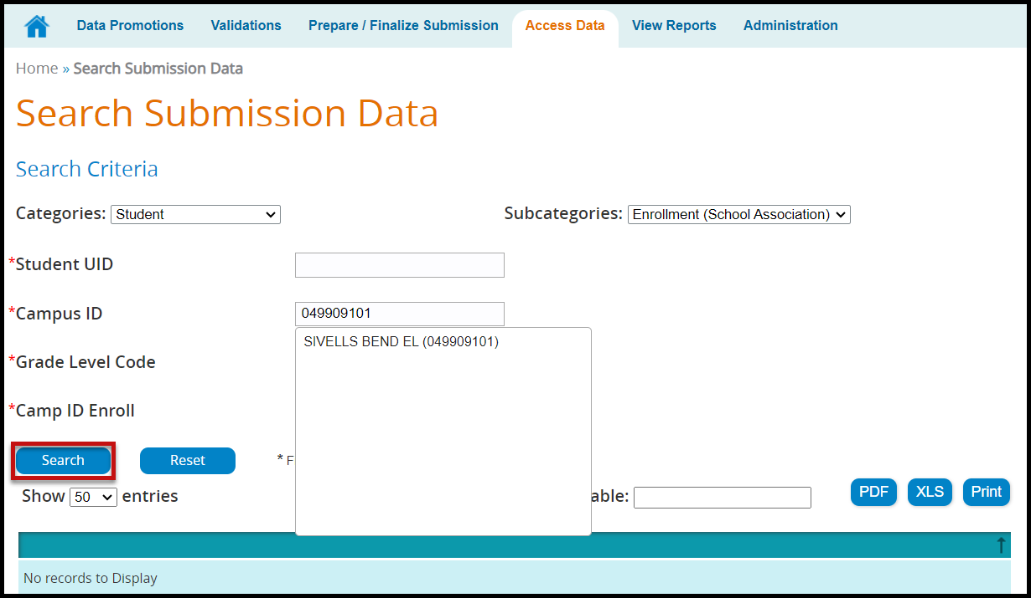
- Click Search to view data matching entered criteria or click Reset to clear selected criteria.

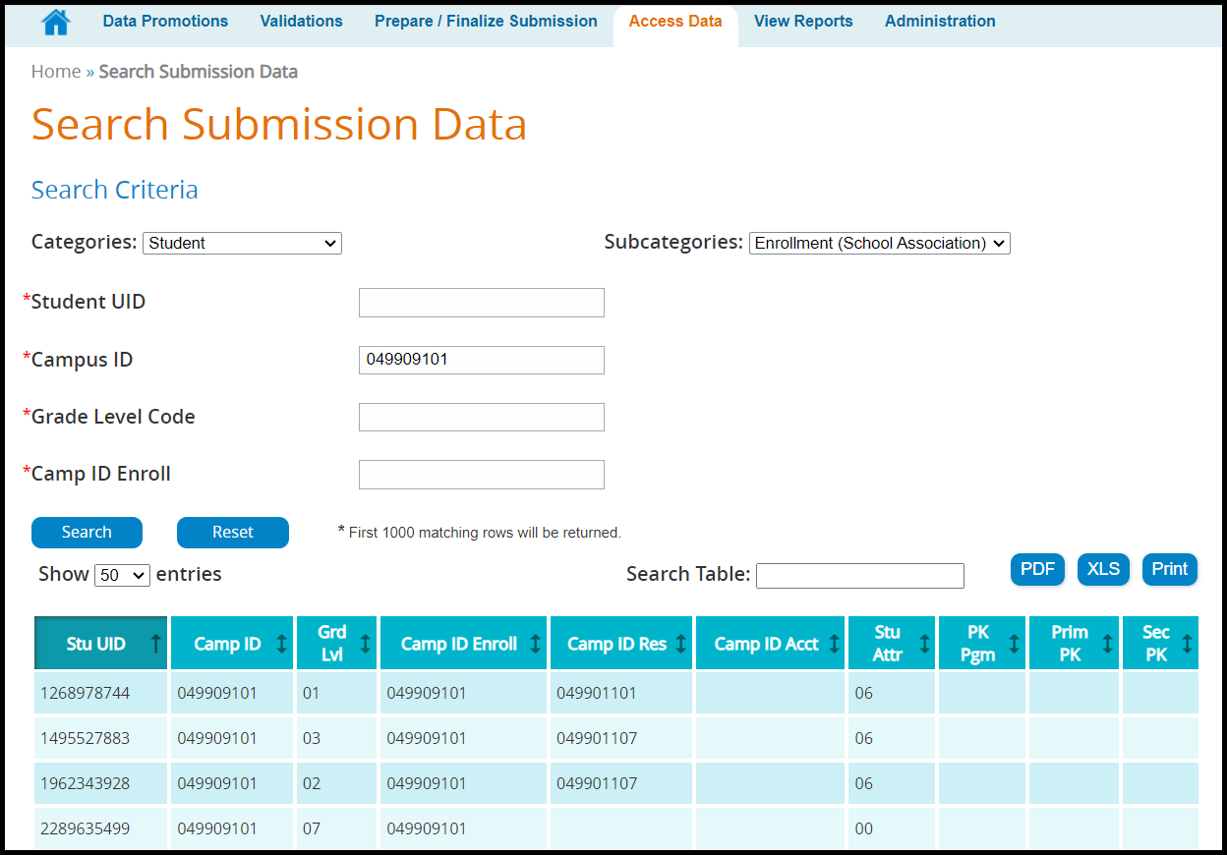

- Show entries allows the user to select up to 500 entries to view at a time.
- The Search Table field allows the user to filter the search by fields. An example would be to search for only 8th grade (enter 08 in the field).
- The search results can be Printed, saved/printed as a PDF or XLS.
- The search results can be sorted by the individual columns by clicking on the column header.

Accessing PEIMS data using Search Student Roster

This search allows districts to search the student roster for specific student data. It is used to help districts with their Leaver data.

- Enter search criteria. Any field with a red asterisk (*) is a required field. At least one required field must be selected to search.

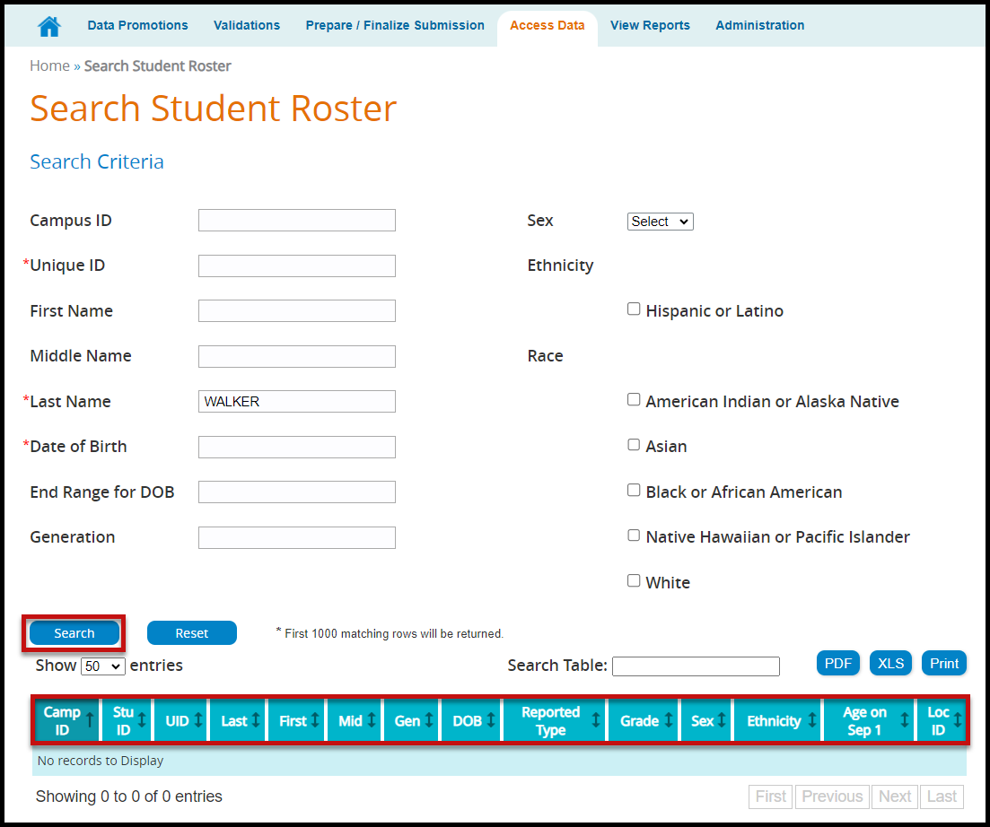

TSDS – PEIMS View Reports

Reports must be run and verified prior to and after completing and accepting the PEIMS data submission. These reports are the same as the reports in Edit+ and must be compared for accuracy of the submission. The TSDS PEIMS reports are separated into three categories:

- Standard Reports – These reports are available at any time and reflect the current data loaded into PEIMS, whether the collection has been completed or not.
- Special Reports – These reports are summary reports that help completers, approvers, and accepters review the data submission. These reports also are available at any time and reflect the current data loaded into PEIMS, whether the collection has been completed or not.
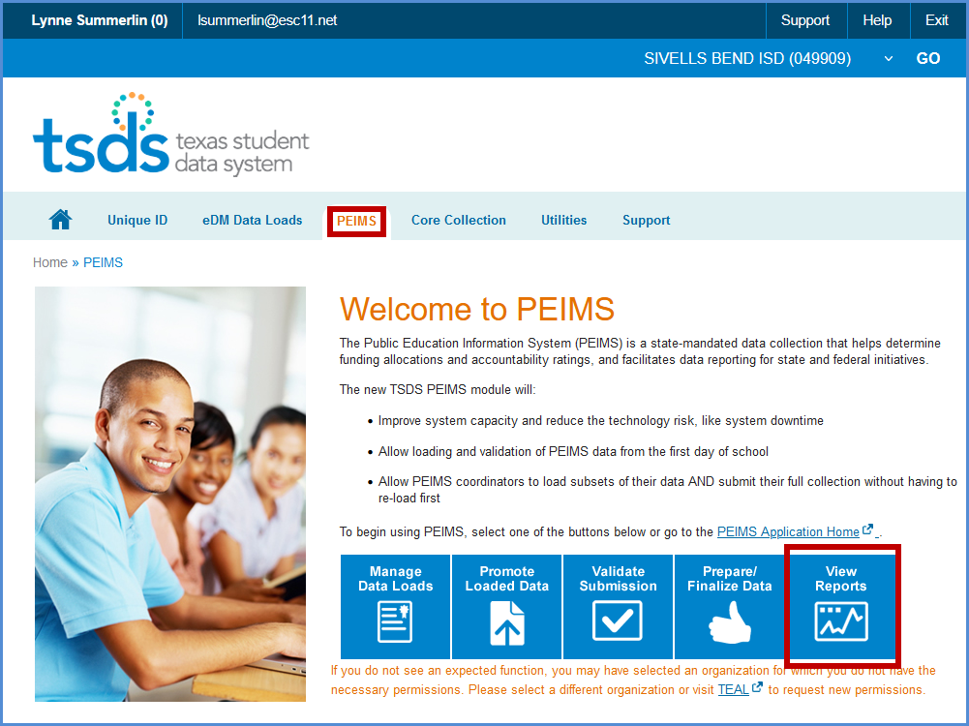
- Student Leaver Reports – These are the individual LEA reports that use data from across the state to help districts identify their leavers. These reports are only in each submission after the submission has closed and TEA has calculated the leavers. These reports only reflect finalized data.
- UID Discrepancies – These reports are used to identify discrepancies between Unique ID data and PEIMS Demographic data.
- Bundled Reports – These are reports that are generated together for ease of downloading.

To access the reports:

- Log in to TEAL and select Texas Student Data System Portal.
- On the Home screen select View Reports. Select the View Reports tab.

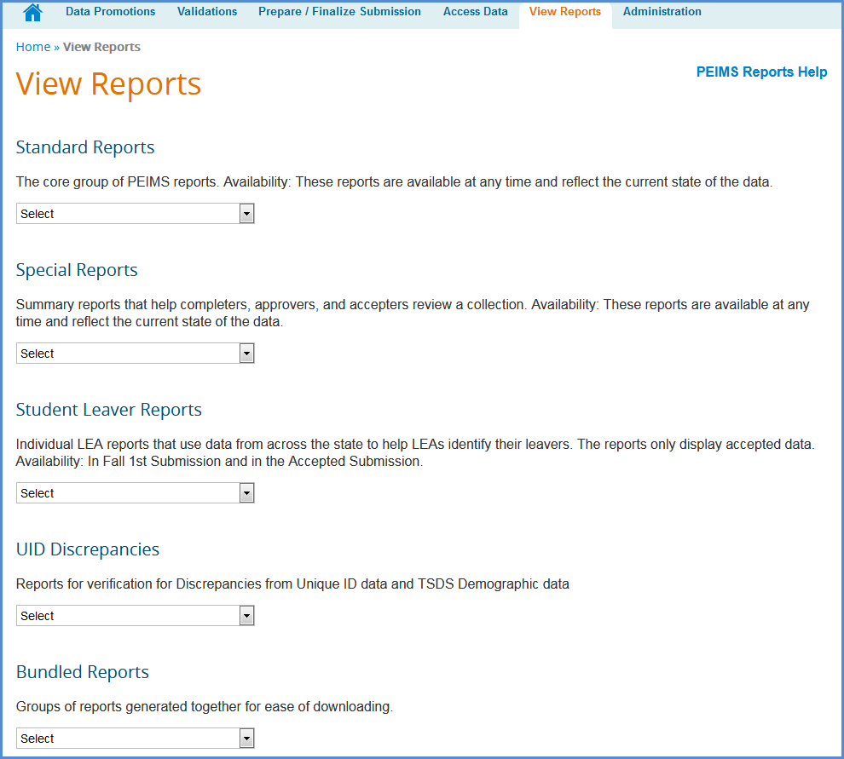
Under View Reports, select from the pull-down menu the report to run in the appropriate category.
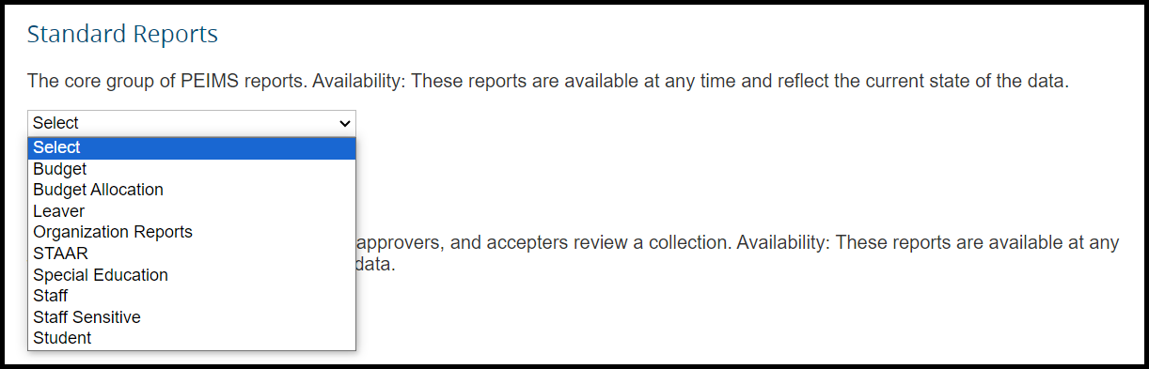

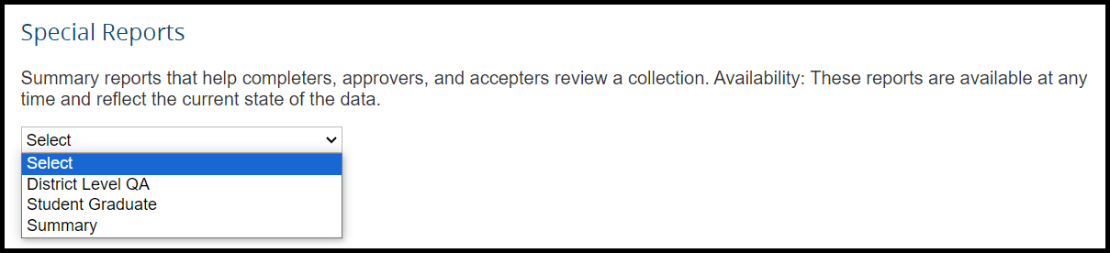
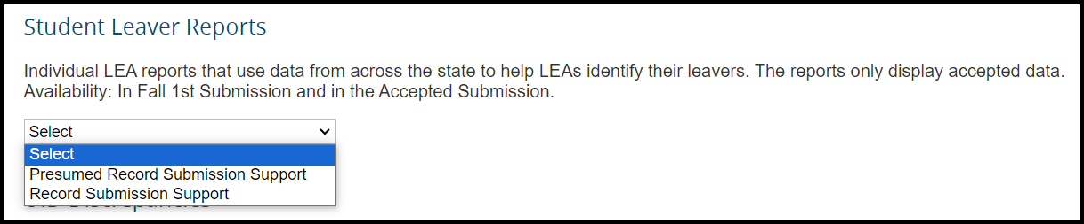
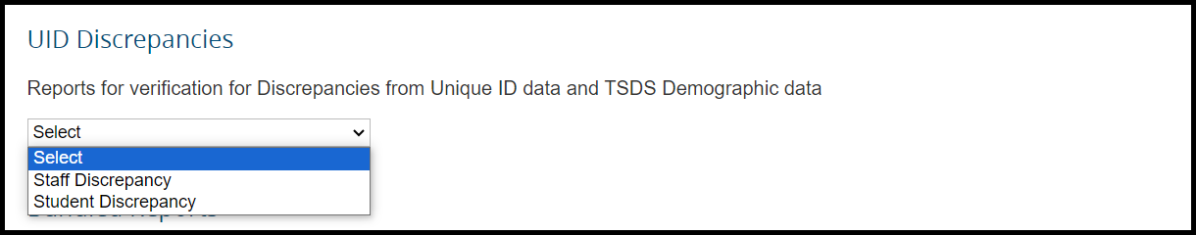
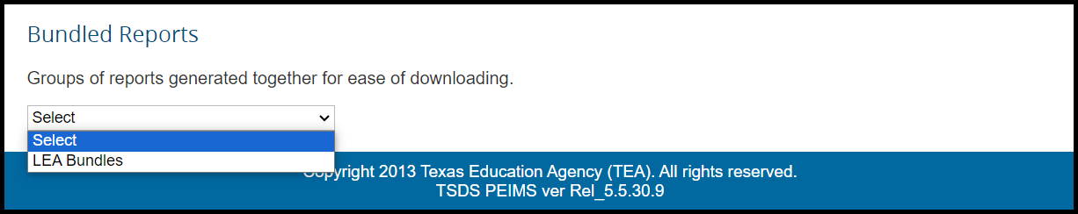

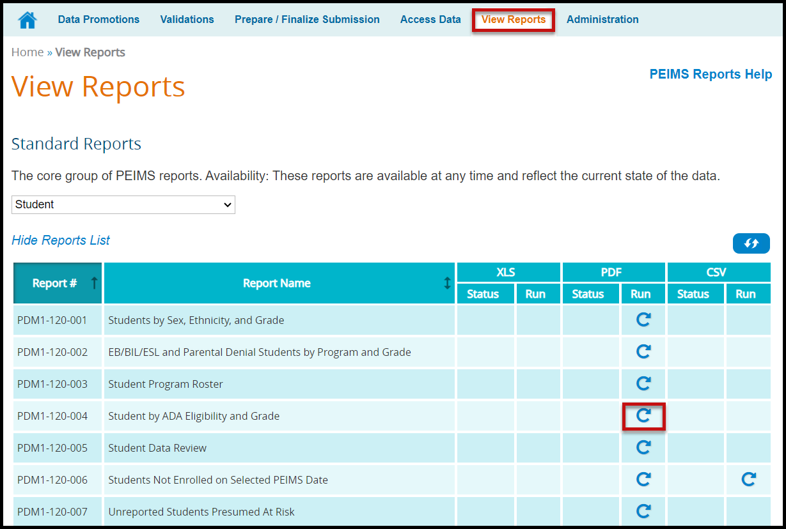

- Click the circular arrow under Run. The Report Parameters screen appears:
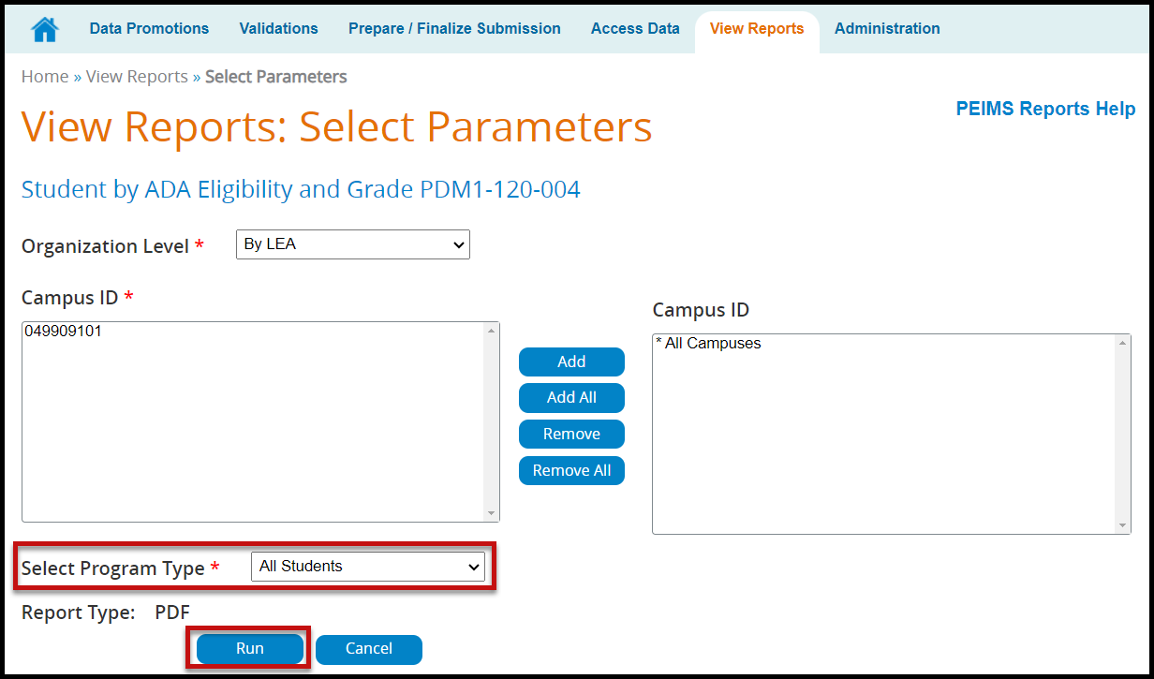

- Reports can be run by district or campus by changing the Organization Level selection.
- Select the appropriate parameters and click Run. The View Reports page appears showing the status of the report. The reports are associated to the individual user to prevent other users from overwriting the reports.

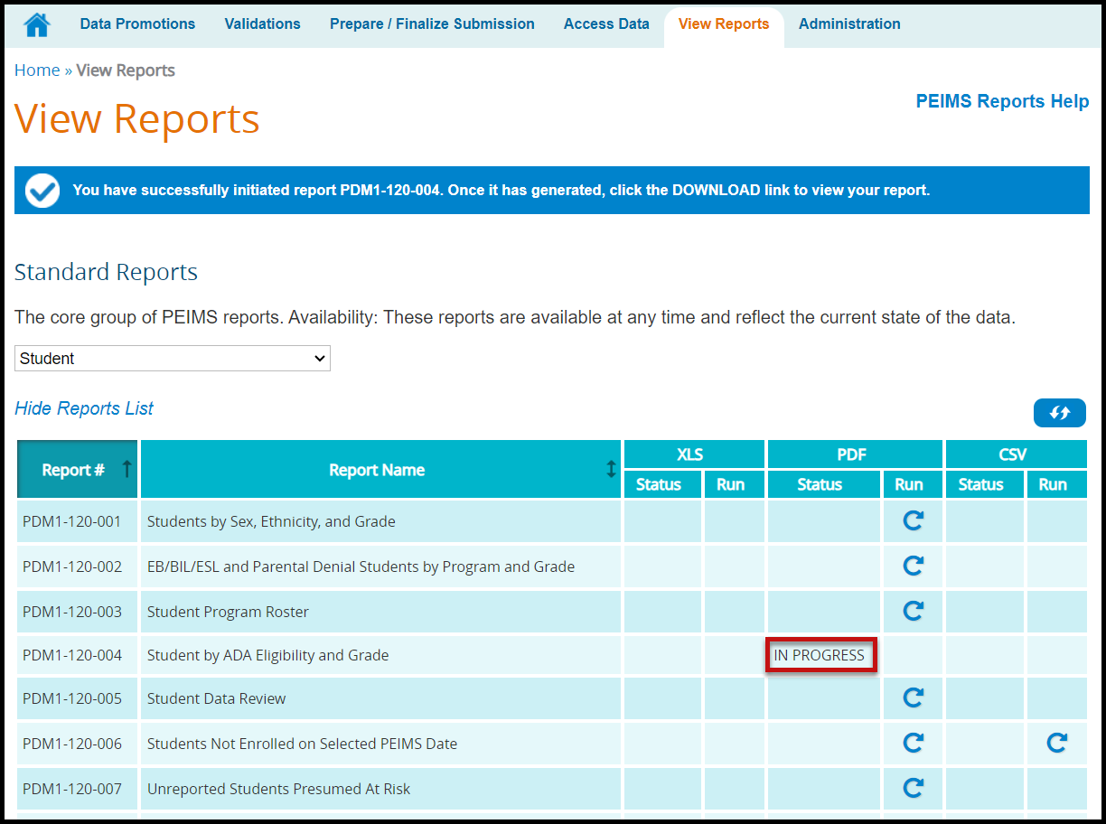

- Once the report is complete a hyperlink will appear, allowing the report to be downloaded.

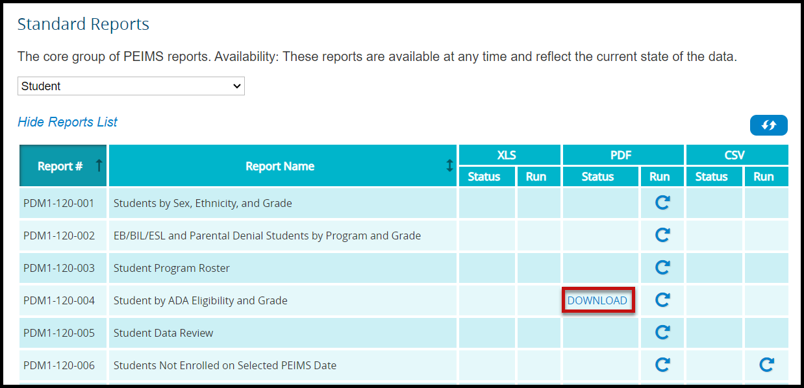

TSDS – PEIMS Prepare/Finalize Process (Sample Screenshots)

Once data has been validated, the district will prepare and finalize the data which will include completing the process so that the ESC PEIMS coordinator can verify the submission. From this screen the district PEIMS Data Completer can lock categories once the categories are fatal free to prevent the data being overwritten.

- Log in to TEAL and select Texas Student Data System Portal.
- On the Home screen select Prepare/Finalize Data.
- Verify that PEIMS is selected from the pull-down menu (if applicable).

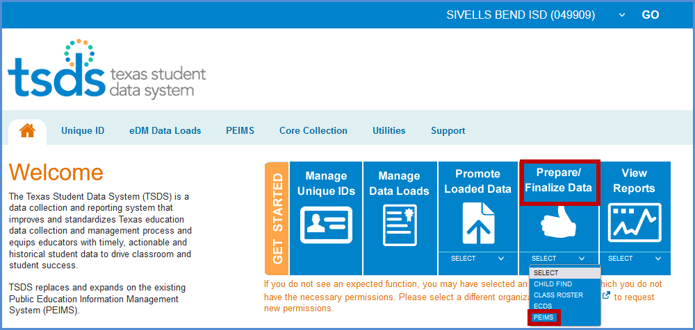

- Verify the correct collection has been selected.
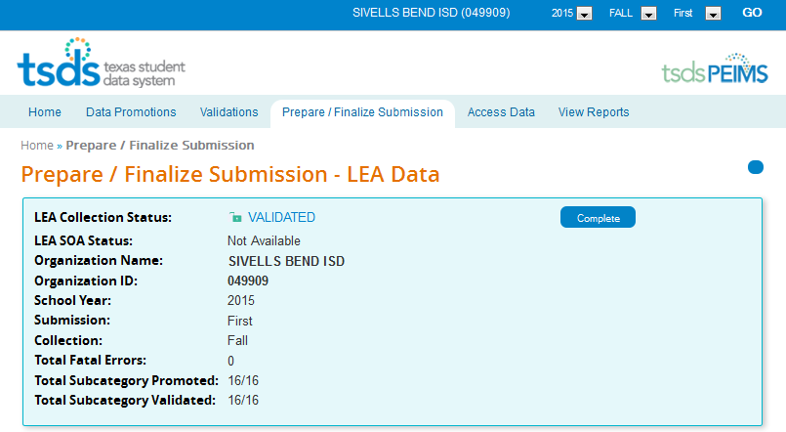

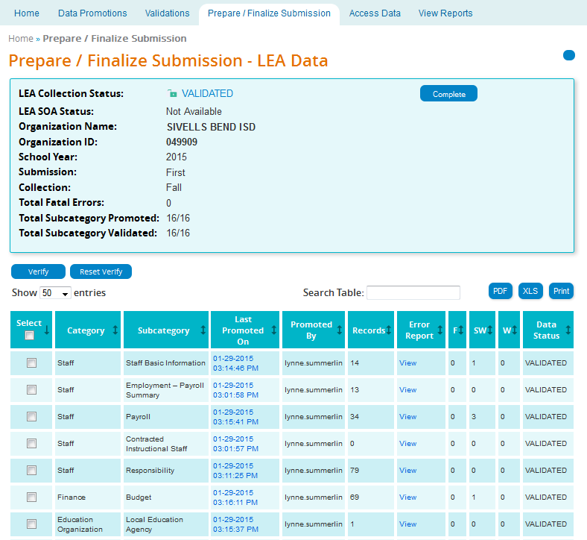

- This screen shows records by Category and Subcategory.
- In the Last Promoted On column is the time date stamp for the last time the data was promoted to PEIMS.
- Promoted By lists the user name of the person that last promoted the data.
- The number of records for the particular Category/Subcategory is listed in the Records column.
- Click View in the Error Report field to view the Fatal, Special, and Warning errors for the particular Category/Subcategory.
- The number of errors by Category/Subcategory are listed under the columns labeled:

- F (Fatal)
- SW (Special Warning)
- W (Warning)

- The current status (Promoted, Validated, etc.) of the Category/Subcategory is listed under the column Data Status.
- The data on the screen can be saved/printed in PDF or XLS by clicking on the appropriate button.
- A search can be done on the screen by using the Search field.
- To verify or “lock” data, the category/subcategory must have a Data Status of Validated. Click the checkbox adjacent to the Category/Subcategory that needs to be verified and click Verify.
- To “unlock” data, click the checkbox adjacent to the Category/Subcategory that needs to be unlocked and click Reset Verify.

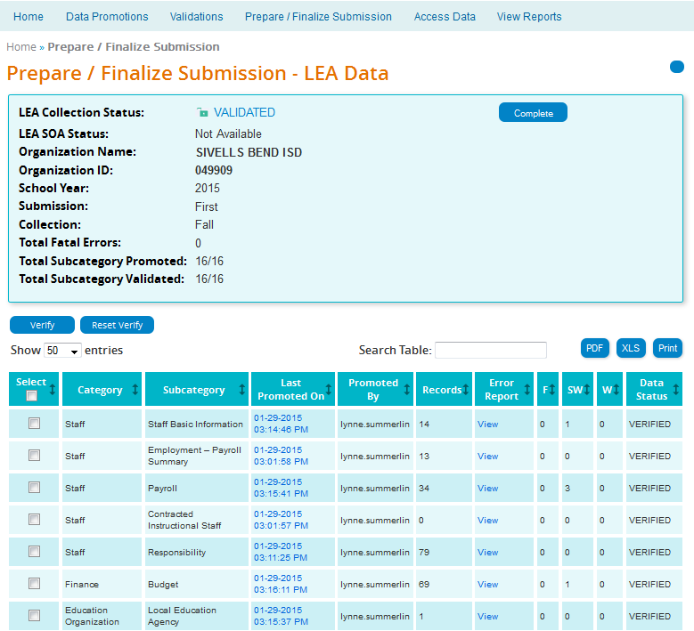

- The PEIMS Data Completer can click the Complete button to complete the file so the ESC can verify data. All files must be fatal free in order to complete the files. The Completion Process Status bar appears:

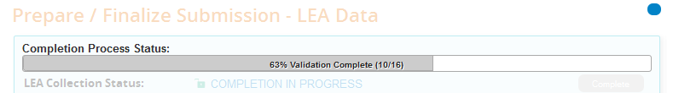

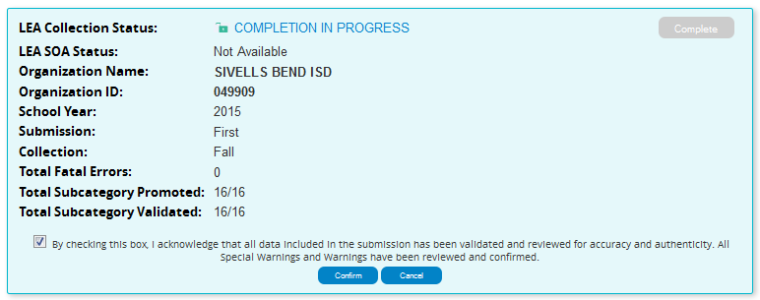
- Once validation process is complete, check the checkbox acknowledging the submission have been validated and reviewed for accuracy and authenticity and that all warnings and special warnings have been reviewed and confirmed.
- Click the Confirm button and the data is now ready for the ESC to verify and accept or reject.
- If rejected the district must correct the data and go through the whole process again.

TSDS – Superintendent Approval Form (SAF) Process

The Superintendent must approve all PEIMS submissions. This is accomplished through the Superintendent Approval Form (SAF) process. The Superintendent may also request an extension for one of the PEIMS submissions. All extensions must be approved by TEA. The district must have extenuating circumstances to receive an extension.

ESC Region 11 grants permission to attendees of this session to reproduce and distribute designated resources and materials provided during the presentation.

