TEAL – Access Application Process (Step 2)

The Texas Student Data System portal is your access to the TSDS Unique ID, TSDS Student GPS Dashboards, and the TSDS Incident Management System (TIMS). You must have TEAL access (Step 1) before you can request TSDS access.

Go to https://pryor.tea.state.tx.us/TSP/TEASecurePortal/Access/LogonServlet . Log in using the Username and Password you created.
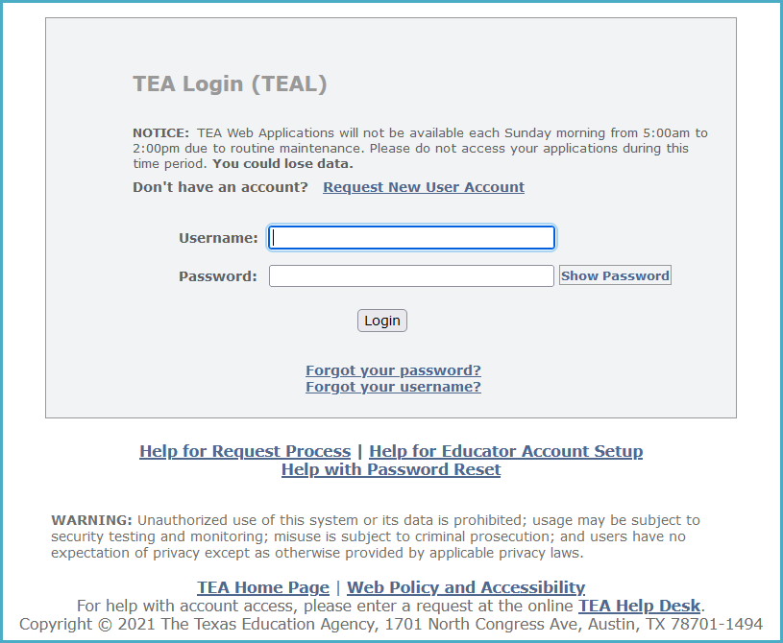

- You will be prompted to select and answer security questions in case you need to recover your password if you forget or lose it.
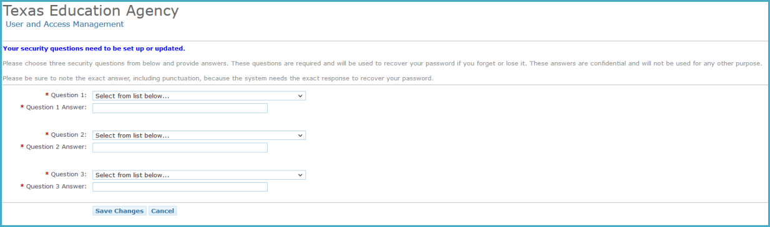

Next, you will be required to agree to the security provisions.

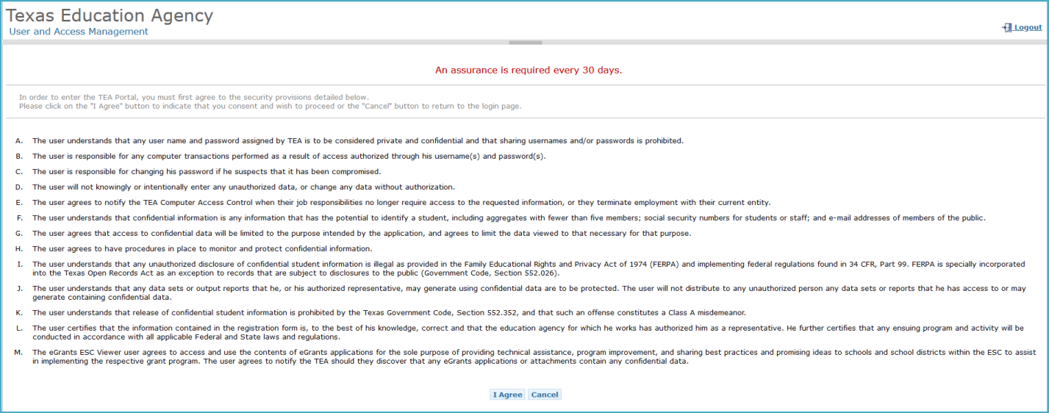

Adding TSDS Access:

- On the Applications tab if you have not been granted access to any applications yet, there will be no links. Click Apply for Access.
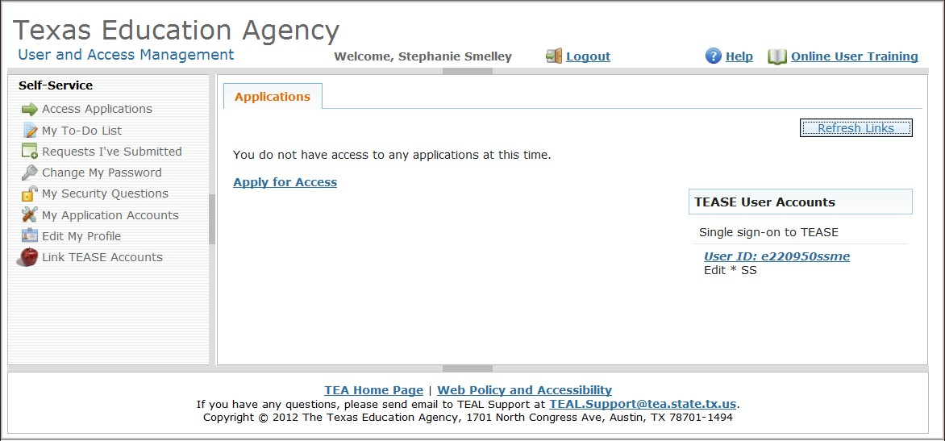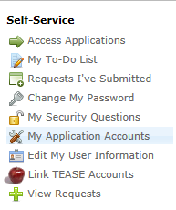

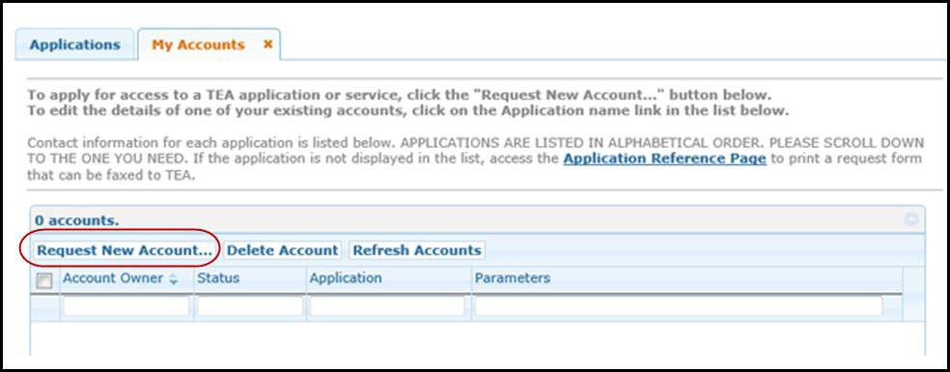
- Click Request New Account.

- Select/Highlight TSDS Portal and click Go to Account Details Form.
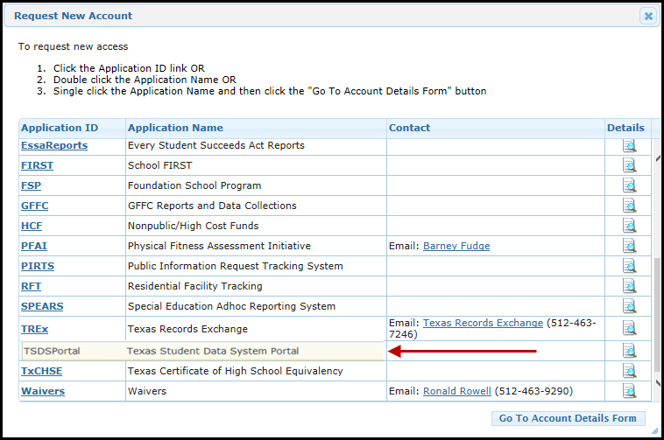

- Click Add Access. The Application access details screen appears:
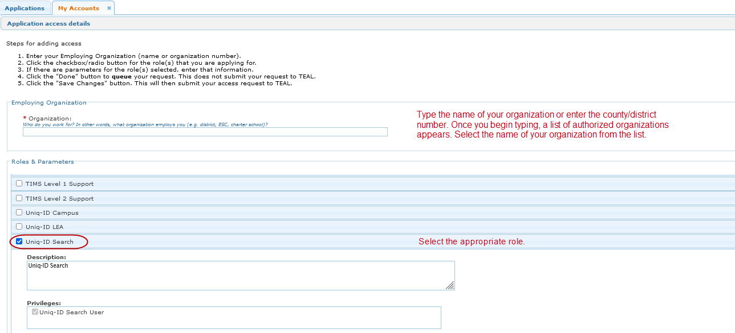

- Under Roles and Parameters select the appropriate role.

Enter any necessary description or comments.
- Click Done.

The Edit Account screen appears.
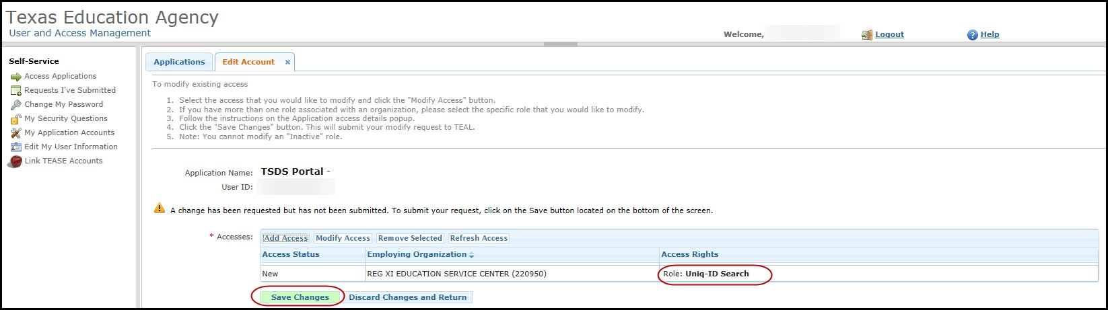

- Verify new role. Click Save Changes.
- Message appears confirming request submission.

- Click Done.

Checking Access Status

A confirmation email will be sent when access has been approved.

- You may check the status of requests at any time by logging in to TEAL and selecting Requests I’ve Submitted.
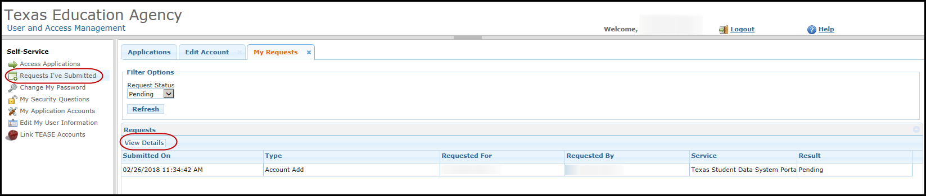
- On the My Requests tab select the appropriate request and click View Details.

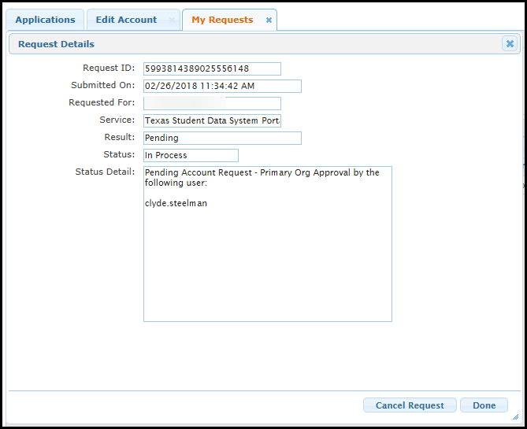

- Click Done.

